Vedanta and “Free will”.

Free will is the ability to choose between different possible courses of action unimpeded. The choice, decision or action is free, independent and voluntary. Free will is closely linked to the concepts of moral responsibility. Praise, guilt, sin, and other judgements apply only to actions that are freely chosen. Traditionally, only actions that are freely willed are seen as deserving of credit or blame. It is also connected with the concepts of advice, persuasion, and deliberation. The underlying questions are whether we have control over our actions, and if so, what sort of control, and to what extent.

Free will is also the capacity to make choices in which the outcome has not been pre-determined by past events. Religion or theology suggests that only one course of events is possible. It is the ordained course of action as per the God’s will. Everyone and everything acts according to God’s will. Free will suggests that events in the world are not pre-ordained by some super power or God.

Free will is also nothing more than freedom of action. Free will is opposed to prohibition. Free will as a psychological capacity is to direct one's behavior in a way responsive to reason.

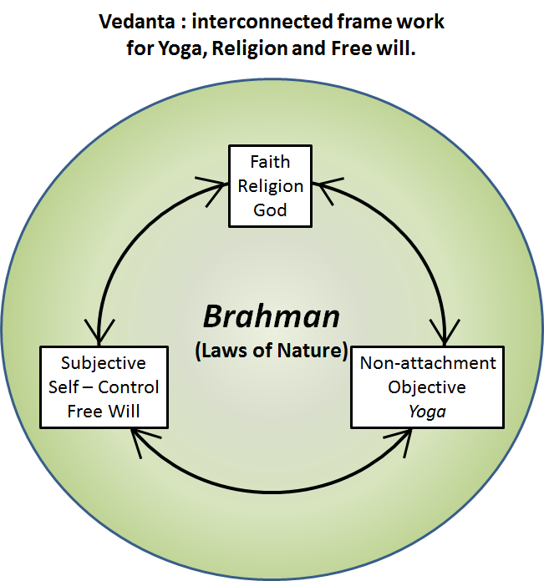
Brahman as we have learned from the Vedic philosophy is the singular term that represents all the laws of nature, the enabler of the Universe. We recognize this presence and role of Brahman through non-attachment. Relinquishing our identity merely through our body, mind and intellect we see ourselves as witness and evidence of the Brahman (Laws of nature) at work. We see the same universality of the laws of nature in anything and everything we can see or relate to. While being individuals we see a seamless connection with everyone and everything. As a result our observation, reasoning, conclusions and actions are objective (inclusive of all and exclusive of none). Any decision and the action as a result is performed with the full knowledge that the prevailing and applicable laws of nature (Brahman) will influence the outcome. Hence I as a decision maker is detached from the outcome, ready to make the next decision and pursue the course as it is called for (duty) with non-attachment and objectivity. Our life and course of action is merely the way of nature. There is no praise or blame. It is like the breeze spreading the fragrance or the rain washing away the soil on its path. There is no blame or praise for the breeze and its effect or the flow of water. It is all part of nature. This way of life, this manner of thinking and action is described as “Yoga”.

The above description of Vedanta infers the following: I am free to observe, analyze, infer, decide and pursue any course of action at any time. In that sense the concept of “free will” is in full display. My engagement in life and the outcomes of my actions are pre-ordained in the sense everything is enabled by and implicitly follows the laws of nature (Brahman). The only constraints or boundaries between free will and Yoga are Non-attachment and Objectivity. If these two attributes are not present or if they are deficient in some manner, then the free will shall be governed by personal preferences (Subjectivity). To the extent subjectivity is involved blame and praise are also the resultants.

In the context of traditional view of “Free will”, self-control can be seen as independence or freedom to think and act on one’s own accord. But from the Vedic philosophy, Self-control (Yoga) implies a willful separation between the observer, the life giving force (the soul or the spirit) while engaging in observation, thinking and action. All these cognitive activities are carried out while keeping in mind that the observer and the observed are connected only through our knowledge, ignorance and bias. This leads to increasing level of non-attachment and objectivity. Thus the Traditional view of “Free will” and the Vedanta point of view of Yoga (Union with the “Self”) to exercise free will merge into each other as our non-attachment and objectivity increases. In other words, to be totally of “Free will” non-attachment and Objectivity are the foundations. Yoga – through our actions, feelings and thoughts – as described earlier are the pathways for such foundations.

We can see, observe and learn of a few laws of nature. But is it possible to accept the view that “everything” is enabled by Laws of nature, known and unknown (i.e.) Brahman? Even if it appears plausible, this requires some degree of faith. This faith is fostered through the description that Brahman created God and from this God the Universe was created. Hence we believe and worship in this God, as part of Vedic religion. We seek to be non-attached and objective. The entity that represents the ideal state of Non-attachment and Objectivity is described as God. If non-attachment and Objectivity increase in our actions and way of life of free will, then the decisions and outcomes are the best one can arrive at. Thus duty is performed without regard or attachment to the outcomes or any praise or blame for that. This way of living is seen as divinity in action!

We can now see Vedanta (Vedic Philosophy) as an interconnected framework for “Free will”, “Yoga” and “Religion”.

Definition - What does Sat-Chit-Ananda mean?

Sat-chit-ananda is a Sanskrit term that describes the nature of reality as it is conceptualized in Vedic philosophy as God or Brahman (Absolute Reality). It is also a term to describe the experience of realizing the unity and wholeness of all existence.
It is said that sat-chit-ananda is the source of all consciousness and all perfection. To experience sat-chit-ananda is to achieve the ultimate goal of the spiritual journey in Hinduism or yoga.
The meaning of the individual words of sat-chit-ananda are as follows:
Sat: truth, absolute being or existence-- that which is enduring and unchanging
Chit: consciousness, understanding and comprehension
Ananda: bliss, a state of pure happiness, joy and sensual pleasure
A common translation of sat-chit-ananda is "truth-consciousness-bliss." Sometimes sat-chit-ananda is considered to be a triple consciousness, where all three elements can be taken separately or considered as one because, in reality, each element is found in everything.
Some say that the experience of sat-chit-ananda is only accessible to a few advanced spiritual masters. Potentially, only 20 or 30 masters have ever been able to reach and remain in this state. It is easier for people to achieve an illuminated mind, but sat-chit-ananda is a higher state even than that.
In the philosophy of Vedanta, sat-chit-ananda is used as a synonym for the three qualities of Brahman. It is the supremely blissful experience of pure consciousness, unity and ultimate reality. Sri Aurobindo considers sat-chit-ananda to be the eternal and unified concept of the soul, which is beyond space, matter and time.

Though it is a lofty goal that may not be achieved in the practitioner's lifetime, practicing yoga can help move the individual closer to sat-chit-ananda. Also sat-chit-ananda need not be thought of as an eternal and permanent state of mind. Such joy and bliss can be recognized whenever our observation, thought, reasoning and/or action is un-attached and objective to the highest order. Learn to observe such moments of Sat Chit Ananda in your life and in the life of others. Let those few moments be the guide as well as building blocks for experiencing the same bliss over long durations and in many actions and activities of life.

https://www.yogapedia.com/definition/5838/sat-chit-ananda
https://sriramanamaharishi.com/faith-heart-grace-reality/what-is-sat-chit-ananda/

