Maintaining Equilibrium in Activities and Life (MEAL)
Basics of Vedanta
(Essence of Vedic Philosophy)

Session1:
Introduction

Session 2:
What is Philosophy?

Session 3:
What is Equilibrium?
The Context for Equilibrium: What is life?
Three kinds of equilibrium
“Experience” – What is it?

Session 4:
“Inner” Person Vs. “External”: Soul Vs. Body
What are “Activities”?
Yoga: Managing life and its activities through the understanding and balancing of the Connectors
Conscience = Connector Science:

Session 5:
Enlightened Person (Yogi)
Who is “I” or What is “it”?
“I” as an individual is none other than
- Material object (Annamaya)
- Living object (Pranamaya)
- Thinking object with “experiences” (Manonmaya) – feelings, thoughts and emotions - governed by or enabled by the connectors (Guna) of Knowledge, Bias and Ignorance - Gunathvam
- Reflective object with reasoning (Vignanamaya) leading to objectivity on the states of equilibrium (Tranquility – Sathvikam, Turbulence – Rajasam and Inertial – Thamasam) enabled by the connectors. Experiences are no longer random occurrences – Sagunathvam.
- Realized object (Anandamaya) in bliss with the knowledge that the Universe (which includes “I”) exists merely as a representation of the Laws of Nature (Brahman) – Nirgunathvam.

Session 6, 7 and 8:
Exploring in depth the five layers (Pancha Kosha) of “I”:
The three pathways for union with the Self (Karma Yoga, Bhakthi Yoga and Gnana Yoga)
- Karma Yoga:
- Bhakthi Yoga:
- Gnana Yoga:
Subjectivity Vs. Objectivity
Beyond Objectivity: Cognitive Vs. Subtle Universe

Session 8 and 9: Nov. 12, 2020 and Nov. 19, 2020.
Vedanta: The essence of Vedic Philosophy
Implications of understanding the Cognitive and Subtle Universe
Western Philosophy Vs. Vedic Philosophy
Vedic Philosophy and “Science”
Co-existent role of Materialism and Spirituality:
Managing Equilibrium in the activities of daily life: Vedic Philosophy as a guide.

Session 10: Nov. 26, 2020 and Dec. 3, 2020
Philosophy, Theology and Science
Brahman: Kenopanishad
Two aspects of Yoga: Union with the self
What is “Ego?” or self-centered nature?
“Professional” as a practicing philosopher

Session 11: Dec. 3, 2020
Managing Equilibrium in Life as a whole
The four pillars of life (PurushaArtha): Dharma, Artha, Kama and Moksha
Four stages in life: Brahmacharyam, Grahastham, Vanaprastham and Sanyasam.
Renunciation Vs. liberation.

Session 12: Dec. 10, 2020.
Yagna Spirit
Maya: Illusion
Bliss: Sath Chith Ananda
MEAL: Vedic Philosophy recaptured:
Spiritual evolution: Where do “I” belong? Spirituality in Practice .

Session 13: Dec. 24, 2020
Review of Questions and answers.
Vedanta and “Free will”.

Session 14: Dec. 31, 2020
Symbolism used in Vedic Philosophy
Symbolism of AUM.
Symbolism of the lamp at the Altar.
Candle or oil lamp and its components.
Yoga and Meditation.
Bird in an open cage.
Brahman: The intangible and the tangible.

Session 15:
Conclusion.

Maintaining Equilibrium in Activities and Life (MEAL)

Session 1: Sep. 24, 2020:
Invocation: Prayer Song
Om, Sahanavavathu Sahanau Bhunakthu , Sahaveeryam Karavaa Vahai
Thejasvina Vadheethamasthu Ma Vidhvisha Vahai
Om Shanthi! Shanthi! Shanthihi ! Source: Krishna Yajurveda Taittriya Upanishad
Let us be protected as we live and learn together; Let us eat and rejoice together; Let there be great energy and enthusiasm as we work together; Let us acquire the glory of wisdom through our knowledge and learning; Let there be no differences or animosity amongst us. Let there be the divine blessing for this Peace and Harmony within, outside and all around
Peace! Peace! Peace!

Meditation:

Discussion:
Question: Tell us why we are participating in this discussion session.
Long Pause and silence.
Question:
Why is there hesitation to speak freely, share what is in our mind?
Answers:
There is a fear or apprehension that others might “judge” me. This creates a fear, apprehension and hesitation.
The silence is gradually broken with the following answers on the “Why am I participating in this discussion session?”
- The discussion leader (Dr. Subbu) has vast experience. May be he will share his experiences; this will give us some guidance to explain our experiences? Give directions in our actions and for our life?
- I think such open forum and discussions can help to spread “positivity”.
- We can revisit our experiences based on what is discussed
- We can learn to think from other’s point of view?
- We need to be more spiritual in our outlook and actions. Is it possible in secular setting?
- Develop a collective and cohesive team at AMTDC that can foster “Self-organizing”
Dr. Subbu:
Excellent set of inputs. Very Good. All of these are good answers. There are few other points I would like to share:
- From my long experience I can draw a few inferences and conclusions. I am hoping to share these with young people so that they can shorten their learning process and increase their effective role in life.
- They say that fluttering of a butterfly in Brazil can lead to a Tsunami in Japan! What it means is that even very small perturbation in any of us can end up as a chaos for the group, team, family, society, etc. So, the more we learn to address and help the hidden anxieties or worries in any of us, it is a great help (without our knowledge) for any and all of us!
- Conversely any one at peace and harmony interacting with others is like a seed or snowflake that gradually builds up into a snow ball (including everyone and everything in the vicinity).
  - My conversations with Prof. Babu and Mr. Dhand started like a snowflake over ten years ago. Now it has grown into a snow ball (AMTDC) – a center of excellence in Manufacturing.
  - I am hoping these discussions on philosophy will help each of you to explore your own inner thoughts and feelings and build an equilibrium or harmony within. Over a period of time let us see what snow balls come out of it!
Srikanth:
We are hoping these discussions can help us build strong team. Of course that requires everyone playing their part like a gear train. In any gear train, each gear has to run smooth and also as an assembly they have to work together. This discussion session on personal aspects of life and living should help each of us to function as a high quality gear or component in the assembly.
Prof. Babu:
Everyone should be clear on the “Why?” for these discussions.
As a response, the above points were re-visited. In summary it was agreed that this discussion session would be useful for (a) Personality Development (b) Spiritual Development and (c) Professional Development
Ajay:
I came with a blank mind. I hope to take one or two points after each meeting. From this meeting I have learned that before starting any effort I should say a prayer and meditate for a few minutes to bring focus and concentration in my mind to the subsequent work.
Sharmista:
In life we always have to do something. Our nature determines what we choose to do. I am very lucky working at AMTDC to strike a balance between my personal and professional life. We need to learn on how to develop and maintain this balance between family, work and other interests in life.

The session ended with a concluding prayer song:
Om poornamadaha poornamidam Poornath Poornamudachyate’
Poornasya Poornamadhaya Poornameyva Vasishyate’
Om Shanthi, Shanthi, Shanthihi !
You are the infinite and the whole; You are full and complete; Nothing can be taken away that will
make you any less; Nothing can be added that will make you anymore; You are that, pure, free and
forever. May this divine blessing of peace and harmony be with you always – within, outside and all around; Peace, Peace, Peace!

Topics for discussion in the future classes:
- In the prayer song why is it said that “let there be no differences amongst us”?
- Sources of fear and apprehension
- Types of Fear
- Someone is “Judging” me: Who is that “Someone”? Who is that “Me”?
- Can we define “Experience”?
- Can we define “Life”?
- How can we define the purpose in life – Personal Life? Social Life? Professional Life?
- Are they different or are they the same?
- Have you ever wondered or thought about “What is life?” “What is the purpose in my life?” Is it different or same as the life of anyone else?”
- Have you thought of “Why am I studying, doing research or working?”
- ”How does my work really connect with my life?”
- ”What is it that I want to do to live an ideal life?”
- “How close or far away I am to that?”
- How does one gauge one’s achievements / accomplishments in this highly competitive world?
- How does a change in perception about life and its purpose will lead to exploration of various paths / avenues in life?
- The difference between living and surviving? ….
Questions from someone from Mars!
- Why do you get up every day in the morning?
- Why did you come to IIT – M?
- Why do you want to study or learn?
- What is Economic success?
- What is emotional success?
- What does it mean to be a better person (peaceful / Tranquil) ?
- What is life?
- What is Equilibrium in life ?

Maintaining Equilibrium in Activities and Living:

Session2: October 1, 2020.
- Philosophy: Think and reflect in-depth to understand the meaning of anything;
Leads to a broad perspective; equilibrium between what is said and what is understood!
(E.g.):
Mother said to her son “Please bring some groceries”: son brought 10Kgs of rice, unaware that there was already 50Kgs of rice at home!
Next day mother said “bring some items for breakfast”: son brought a dozen eggs (as he has changed in his habits and life style) forgetting the fact that mother is still a vegetarian!
Finally mother said “Please bring some vegetables for cooking”: son brought some vegetables, but did not bring Green chilies, onion, ginger, coriander, etc. needed for cooking a nice and tasty vegetable dish!
The request “bring groceries” from mother and what the son brought home on three different occasions reflect the common experience in the gap between what is said and what is understood!
Philosophic reflection on any subject and topic should become natural for every one – all students, engineers and anyone. This is a lifelong process!
As an example, let us look in-depth at the Prayer Song:
Om, Sahanavavathu Sahanau Bhunakthu , Sahaveeryam Karavaa Vahai
Thejasvina Vadheethamasthu Ma Vidhvisha Vahai
Om Shanthi! Shanthi! Shanthihi ! Source: Krishna Yajurveda; Taittriya Upanishad
Om, Let us be protected as we live and learn together; Let us eat and rejoice together; Let there be great energy and enthusiasm as we work together; Let us acquire the glory of wisdom through our knowledge and learning; Let there be no differences or animosity amongst us. Let there be the divine blessing for this Peace and Harmony within, outside and all around
Om, Peace! Peace! Peace!
Let us be protected as we live and learn together – This Invocation seeks the blessings
Let us eat and rejoice together:
“Eat” here refers to “What we consume” as nourishment. Forms of “Nourishment”:
- Material or tangible: Food (nutrients and the source of energy).
All the nutrients we consume come from the five elements of nature:
Air (for breathing)
Water (to digest and also to hydrate and maintain the balance of the various fluids in our body)
Minerals and Hydrocarbon (Earth)
Heat (Thermal energy)
Space (What is left over)
- Perceptions, Emotions and Feelings: Intangibles which make each of us who we are as “individuals”.
- Driving forces (Laws of nature)evidenced through :
  - Consumption, Digestion, Assimilation, Excretion, Conversion for equitable distribution (AnnaMaya)
  - Life processes (Biology, Physiology, …..) (PraanaMaya)
  - Experiences and their outcome (ManonMaya)
  - Analysis and Reasoning (VignanaMaya)
  - All driving forces known and unknown (AnandaMaya)
Our rejoicing or celebration in life come through our
Physical fitness: Eating, Health, Exercise, Yoga, ………..
Biology, Physiology,
Emotional Comfort: Music, Arts, Social interactions, Group events, Meditation,
Prayer
Psychology
Intellectual Contentment: Studies on any subject, Reflection, Analysis, comprehension and Internalizing and the
inner peace or comfort they facilitate.
Note: Two common words “Eat” and “Rejoice” when reflected upon shed so much details and profound understanding of what they mean and how they are applicable in our daily life! That is the power behind Philosophic thinking!
Let there be great energy and enthusiasm as we work together;
Let us acquire the glory of wisdom through our knowledge and learning;
Let there be no differences or animosity amongst us.
Learning has to promote focus on a common language, an understanding of the subject matter that is comprehensible to everyone.
Differences or animosity disappears when there is emphasis on “learning”.

Know the difference between:
Knowledge, Learning and Understanding (Gnanam, Gyeyam, Gnanagamyam).

Let there be the divine blessing for this Peace and Harmony within, outside and all around.
The word Peace is repeated three times to signify peace and harmony in every way we can identify ourselves as the “I”, such as:
Through body, mind (emotions) and Intellect
  - Body - Perception: Anything we See, Smell, Hear, Taste and Feel/touch
  - Mind - Feeling (Emotion)
  - Intellect - Whatever we learn (Thoughts, ideas, concepts, information, knowledge, ….)
- The External - outer, visible, tangible or cognitive self, 2. The inner - Intangible life giving force, Consciousness, Soul or Athman AND 3. the Universal source of energy, Universal Consciousness, God or Brahman

Om in Upanishad stands for “Everything” – the Universal (Mandukya Upanishad).
Om is the combination of the longest and shortest sounding letters in the alphabet
(i.e.) from beginning to end!

Philosophy: in-depth and analytical understanding of any subject on hand. This is why we get Doctor of Philosophy (Ph.D) as the highest degree in any field of study.
In-depth study of aspects of “what is life?”, “How to live in equilibrium (with peace and harmony)?” is now recognized as “The Philosophy”!
Discussion:
- There are many great writers and scholars like J. Krishnamoorthy. Students and engineers are encouraged to read and reflect on their books.
- We go through various phases at different times in life such as:
    - Conscious – reflections of right vs. wrong
    - Unconscious
    - Subconscious – “I have a feeling that this is the right thing to do”
  - Everyone goes through these phases
  - Reflection of oneself is a good turning point for everyone for internal equilibrium which in turn helps external equilibrium. Remember: A fluttering butterfly in Brazil can lead to Tsunami at Japan!
  - Not everyone is comfortable to search and look within oneself.
  - But, we need to understand that there is a purpose to look within, with an open mind.
  - Participation in the group discussion leads to absorption, retention and eventually leads to practice.
- There is another approach to life like that of great saints and masters. They did not worry about their immediate life and needs. Instead they spent their life thinking about larger aspects of life. We think of them and revere them even after many centuries.
  - With Gandhi Jayanthi on Oct. 2nd (tomorrow) it is good to reflect on this approach to life as well.

Maintaining Equilibrium in Activities and Living:

Session 3: October 9, 2020.
What is Equilibrium?
Equilibrium = Maintaining balance between two competing needs, forces, directions, etc.
In order to establish “Equilibrium” we need to define the context and the competing needs, forces, etc.
Examples:
- Force equilibrium, Thermal equilibrium, Price Vs. Demand (price elasticity), Quality Vs. Production rate.
- Student wants to pass the exam; Teacher wants the correct answers. Performance in the test determines the equilibrium!
- Bicycle is in equilibrium when it does not tilt to the right or left, when riding.
- Inflated balloon is in equilibrium when the stretched membrane through its surface tension balances the air pressure inside.
- Judge tries to achieve the balance between the crime and the punishment
- In love between two people (child and mother, two youngsters, parents and children, teacher and students, citizens and the nation, etc.) there is balance between the affection expressed and the affection reciprocated!
“Equilibrium” establishes the sustainability and progress.

The Context for Equilibrium:
What is life?
Life is a collection of “Experiences” – Vasana - acquired through our activities.
We engage in activities through our:
- Body and its functions leading to “perceptions” of “Objects” and the experiences as a result.
- Mind and its functions leading to “feelings” of “emotions” and the experiences as a result.
- Intellect and its functions leading to “thinking” of thoughts and ideas and the experiences as a result.

Life is a constant search for equilibrium between:
What I sense, or perceive (See, hear, feel, taste, smell, etc.) Vs. What it is?
What I observe or feel (as emotions, views and opinions) Vs. What it is?
What I think or reflect (as thoughts, ideas, views) Vs. What it is?


Three kinds of equilibrium:
Every merchant uses a balance to measure the weight to sell vegetables.
Knowledge / Tranquility (Sathvikam):
No matter what he sells, the item sold for a given weight (verified against set standards) is always the same! This implies that his balance, weights used, method of weighing – all follow the same standards and procedures. Everyone in this store (uses the same balance, weights and process) gets the same result. People trust this merchant, each other, his balance, weights and procedures. In fact, over time this shop became the standard for honesty and integrity. Every one respects this store and prefer to interact (shop) with this shop.

Turbulence or Bias:
Whenever he sells, the expensive items come out below the promised weight, but it is not a problem for inexpensive items. When people complain and on weighing again somehow the expensive items needed few more pieces to reach the correct weight. But such re-weighing is not always done. Usually it follows a quarrel from an angry customer and his complaint. Sometimes the problem goes away when there are other workers at the weighing station. Each day the merchant went home upset and unhappy, but the situation was no better or different next day!
A secret observer found that the merchant was putting his thumb in the scale (bias) to make more money off the expensive items, affecting the results based on his personal desire, greed, wanting to do favor for one customer over the other, etc.


Ignorance or Stagnation:
For this merchant, there was never a case of getting the correct weight. No matter who tried to weigh it was never correct. Even others could not help. Sometimes even the customers themselves were asked to weigh. Even they could not help to get items at the correct weight. Suspicion and uncertainty was growing. It became a habit for most people to go to the first store and check their items to see how much more or how much less they got this time!
One day an innocent child tipped the balance over. The merchant found a piece of metal was stuck to the bottom of one of the pans! The merchant ignorant of this has been growing upset and feeling relentless grief as long as he was clueless.

“Experience” – What is it?
Sattvam rajas tama iti gunah prakrti-sambhavah
Nibadhnanti maha-baho dehe dehinam avyayam BG 14.5
Our balance between the person (body, mind and intellect) as the probes of the external world and the soul (the person inside the body) is established through three ever present connectors or links(Guna).
These connectors are: Knowledge, Bias and Ignorance.
These connections create three sets of equilibrium (like the three ways of using the balance in our example above).
Through the outcome or combined effect of these equilibria, we acquire our “Experience”.

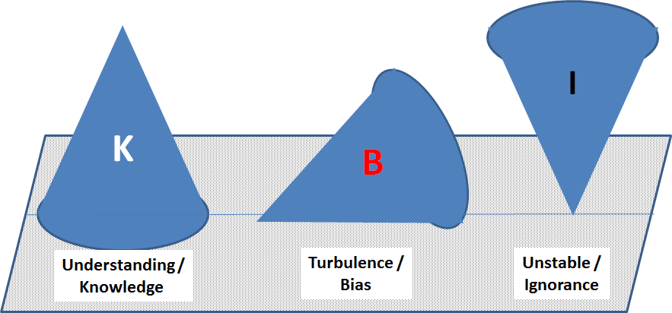

Rajas tamas cabhibhuya sattvam bhavati bharata
Rajah sattvam tamas caiva tamah sattvam rajas tatha BG 14.10
These three sets of equilibrium always co-exist. All our perceived experiences are the outcome of the dominance of one mode of equilibrium over the other two.

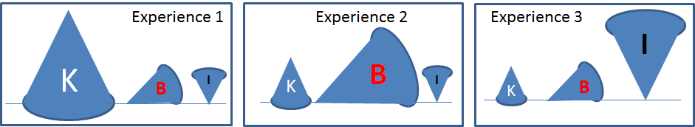

 | Experience 1 (Tranquil) | Experience 2 (Turbulent) | Experience 3 (Inertia)
Source | Study, Knowledge, Reflection and analysis | Driven by personal needs and unbridled attachment | Ignorance, lack of effort even to try and observe or learn
Outcome | Tranquil, Understanding,  reliable at times of need | Turbulent,  angry/upset, happy /sorrow,  “moody”! Unreliable at critical moments. | Unrelenting grief, lack of direction, procrastination.  Not reliable.
Evidences | Comprehension and agreement all around;  Collective progress;  Success and failures are both accepted with appropriate next steps.  Equal at ease at all places and times and circumstances. | Always “busy”, chain of actions each leading to the next without satisfaction; a sense that the desire or needs are never fulfilled, pretentious,  blaming others | False hope, blaming everyone at random, hallucination, depression, unrealistic expectations, far beyond means, uncontrolled mind,
Maintaining Equilibrium in Activities and Living:

Session 4: October 15, 2020.
“Inner” Person Vs. “External”:
All sources of energy (forces of nature) are invisible, have no property of their own. We recognize them through their effects or through observations that reflect their effect. (e.g.): Electrical energy that powers a circuit and activates the light bulb to glow. Gravitational force, Magnetic field, Chemical reactions, Digestion and assimilation, Deformation, Friction, ……..
Each of us is enabled by a source of energy or the life giving force. We recognize that through the activities we engage in. (e.g.): Heart beats and creates the pressure for the blood flow, lung breaths and creates the air circulation, digestion, vision, smell, touch, taste, strength, etc.
This invisible and intangible life giving force of nature or the source of energy is defined as the SOUL (Athman) or the “inner person” (Dehinam – the entity inside the Deham: the physical or tangible person).
What are “Activities”?
Activities: Anything that happens as a result of our engagement with the “external” through our body, mind and the intellect.
- Through our body (Physical functions and sensors) we become active and aware of the world around us.
- Through our mind we perceive this awareness as our emotions and feelings.
- Through our intellect we think, reflect and analyze our awareness and feelings and develop our thoughts, ideas and opinions.
Activities are events occur instantly, over time; accumulate over a period of time, …………
Activities can be
- Personal actions, Social activities, Group activities, Natural events, Universe of activities, Universe as a whole!
Each activity or event adds to our pool of “Experiences”. Hence Life is a collection of “Experiences”.

The Sanskrit term for activities: Karma.
In all languages many words have different meaning depending on the context. Here are some common uses for the word “Karma”:
- Any action or activity (Yogaha Karmasu Kaushalam: Reflection and Analysis (Yoga) enables the skill required to engage in any activity). B.G. 2.50
- Action that is appropriate for the moment (as a duty) (Karmaani Yeva Adikaarasthe’: You are responsible to engage in actions considered as your duties). B.G. 2.47
- Rituals required to be performed (Karma as part of tradition).
- Action or effect that is pre-ordained (e.g.: Law of Karma)
Like any other word, meaning of “Karma” can change with the prefix, suffix or adjoining words. Few examples:
- Nitya Karma: Daily activities (which when avoided lead to decay and harm; when pursued lead to good health and stability.
- Naimittika Karma: Obligatory actions.
- Kamya Karma: Actions towards a larger goal or objective.
- Yagna Karma, Dhana Karma, Tapah Karma: Activities pertaining to prayer, Charitable activities (giving gifts, donations), Prayer and meditation B.G. 18. 5.
- ……………
Be aware of the “Experiences” relating to people, feelings, ideas, things, data, etc. They are all reflections of the connection with the “external” through one or more activities or a collection of them over time.
Look for the connectors as the ropes (Guna) and their relative proportions! (Reference: Session 3).

Yoga: Managing life and its activities through the understanding and balancing of the Connectors:
All of us exist all the time, in the world of activities. They are both voluntary and involuntary activities. We engage in these activities from birth to death.
Birth is the moment when the life giving force - the inner person (Dehinam: Soul or Athman) – is perceived in our physical existence (Deham: body, mind and Intellect) through our activities!
Death is the moment when the life giving force (Athman) is no longer perceived and all activities of our body and its function cease.
Analogy: Electricity flows through a closed circuit. Electric flow ceases in an open circuit!
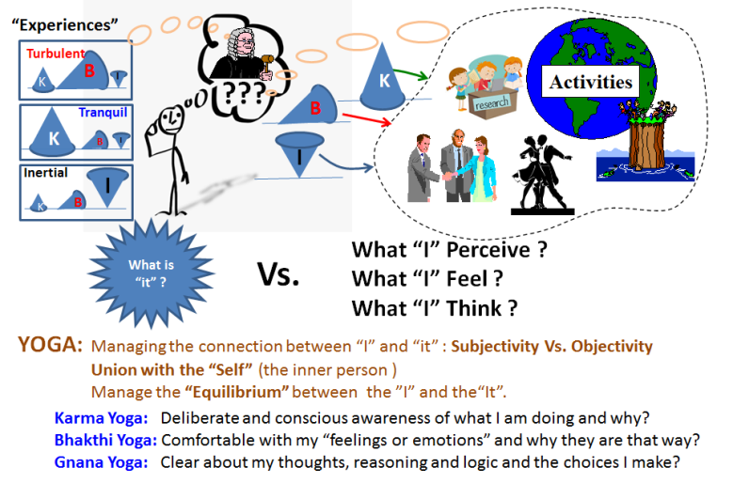
All activities can be grouped under Physical, Emotional and Intellectual events.
We acquire “Experiences” as a result of these activities. Hence we can consider life as “collection of experiences” acquired through our life and its activities.
Managing equilibrium in our activities and in the life as a whole would mean understanding the sources of “experiences” and how to balance or rebalance them.
The desired outcome:
Genuine inner peace and harmony!

We have also understood that every experience is a response to our knowledge, bias and ignorance to that activity. We have also understood that these three co-existing connectors can occur in differing proportions, which in turn establish the true nature of our “experience”.
Like the flow of electricity illuminates the light bulb in a closed circuit, “I” as an individual or we (a collection of “I”) function through our activities when the life giving force (Athman) is perceived through the actions of the universe (through body, mind and intellect in each of us).

Yoga (Union with the self) is the process of engagement, reflection and analysis to recognize the difference between the life giving force and its perception through the effects (like the electricity and its perceived role in the electrical circuit or illumination of the light bulb).
Yoga is the science of exploring our “experiences” and laying the framework on why “It is that way”. With Yoga experience becomes an event explained and understood rather than as an unknown effect. This understanding leads to equilibrium, balancing, choices and corrective actions in our activities of life!

Conscience = Connector Science:
We are deliberately and willfully in union with our “conscience” when we reflect on the “connectors” at play and their relative proportions.
As a result we don’t see an angry person. Instead we see a person who appears disturbed (angry) for some known and unknown reasons! We are not just experiencing happiness or sorrow, but we know why as best as we can configure. We don’t merely see data or observations and react based on that, but seek to understand the “Why?”

Discussion:
Activity | “Experience”
Activity | Context: | Tranquil (Sathvik): | Turbulent (Rajasic): | Inertia / Ignorance (Thaamasic)
Activity | - Time period:  - Momentary,  - over a period of time,  - Accumulated over a period of time.  - Purpose of our analysis (Why?)  - People involved  - Means or circumstances  - Laws of nature. | Knowledge and Understanding, prevailing over Bias and Ignorance. Measured activities, purposeful with generally satisfactory outcomes for all. | Personal attachments, preference and bias dominant over Knowledge and Ignorance.  Relentless chain of activities with no stability or peace at sight! | Ignorance dominant over Knowledge and bias leading to unrelenting grief,  lack of direction and procrastination.
- Fear or Apprehension.
- Writing a report
- Giving a gift
- Happiness
- Personality
- Food we consume
- Knowledge

Maintaining Equilibrium in Activities and Living:

Session 5: October 22, 2020.
Thus far we have covered:
- What is Philosophy? – Analytical and in-depth exploration to gain better understanding of any subject.
  - Philo = Love; Sophy = Wisdom; Philosophy = Love for Wisdom (Quest for in-depth knowledge).
- Philosophy of life implies – Learning “What is life?” and how to manage the activities of life to maintain and promote peace and harmony.
  - Since “life” includes any and all aspects, our study and learning from “Philosophy” should be applicable to any aspect of life – be it professional work, research work, family life, health, education, friendship, national economic matters, politics, civics, …………… !!!
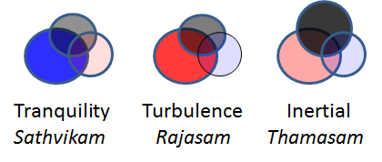
- Life is a collection of “Experiences”: Impressions we acquire as a result of our three ever present connectors (Guna): Knowledge, Bias and Ignorance.
- All our experiences are none other than the projection or representation of three modes of equilibrium:
Tranquility (Sathvikam), Turbulence (Rajasam) and Inertial (Thamasam), due to the predominance of one connector over the other two!
- Self, Soul, Spirit or Consciousness – Athman is the driving force or life enabler (like the invisible electrical energy that activates the electrical circuit). The ever present connectors (Guna) link the soul or spirit as we engage our body, mind and intellect with the external through countless “activities”.
- Yoga (Union with the Self) is the process of reflection and analysis to observe the connectors at work and their roles as evidenced through the three equilibrium states. Through Yoga our “experiences” are no longer random occurrences. Instead they are the logical outcome of our K,B and I pertinent to that experience.

Enlightened Person (Yogi):
  - The equilibrium states composed of Knowledge, Ignorance and Bias are NOT permanently attached to anything. They merely represent the nature of our connection and the relative magnitude of the connectors in the context of time, place, information, people and circumstances.
- An enlightened person recognizes that all the effects around him/her arise out of the connectors (Guna). B.G. 14. 23
- Such enlightened person has a firm and balanced frame of mind, where opposites such as happiness and sorrow, dear and not so dear, praise and blame are treated as equal in effect. He/she has a value system, where a piece of clay, a stone and a piece of gold are of equal significance. B.G. 14.24
  - For an electrician the glow of incandescent bulb Vs. LED light is all the same; driven by common principles (the way any electrical circuit and the bulb work)!
  - A true professional is a “Yogi” in that he/she:
    - Remains unattached to all observations and merely seeks to explore and/or apply the basic principle (Science – Laws of nature) at work, while aware of the context and boundary conditions!
    - When ignorant of the laws of nature at work or uncertain of it (biased) pursues efforts relentlessly to enhance such knowledge.
- Such a person consistently observes the role of the three connectors (Guna) in honor and dishonor; in friendship and enmity (like they were the glow of a red light vs. green light)! B.G. 14.25
  - Hence there is nothing Tranquil, turbulent or inertial as permanent identifiers of any person, object, event, situation or circumstances.
  - Pointing to a house the wise man said “go to that house where the bird is sitting. That is the house you are looking for”. The foolish person kept chasing the bird looking for his target house!
      - Such permanence in our thinking about anything – the context or the connectors or the three modes of equilibrium - is like mistakenly believing the shadow to be the object, hence missing both the object (ourselves or the reality of the situation) as well as the source of light – the laws of nature recognized as the life giving force, soul or Athman.
  - Ego or self-centered notions are destroyed when the true nature of the Self is realized as distinct from the subjective aspects of the world which we call as life. Athma Bodha (Knowledge of the Self) 44.
  - On realizing the true nature of the Self, the false notions of “I” and “mine” disappear
Athma Bodha (Knowledge of the Self) 45.
- Such a person does not initiate any actions based solely on personal or self-driven needs.
- The mistaken identity of all that is cognitive as the only real is described as “illusion” (Maya).
- Hence, enlightened living implies managing the equilibrium and the role of the connectors in any and all our activities of life (Yoga) such that experience becomes a logical outcome. This is opposed to a view that events and experiences in life occur as random events or in alignment with pre-conceived notions, opinions and judgements!

Who is “I”? or What is “it”?
If each of us are activated or energized by soul (a droplet of water from a large body of water), then
Where does the notion of distinction between each of us arise?
How is it that “I” am different from “you” and “others”?
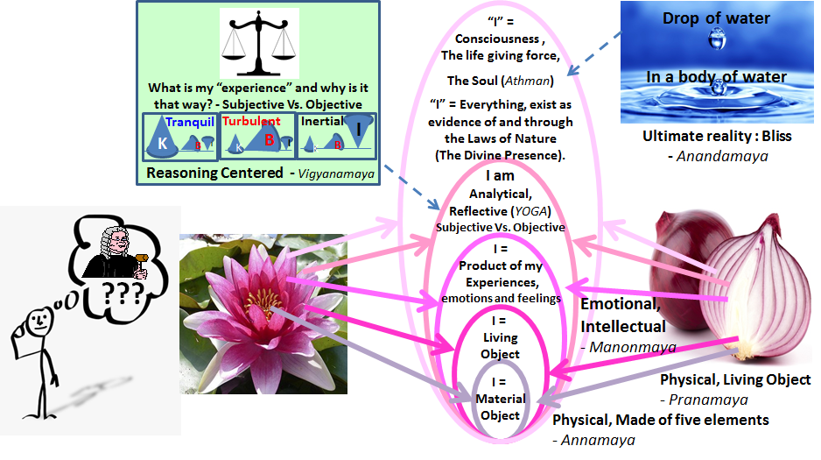
“I” = Material Object:
If we think carefully everything in the Universe is made of matter. We study and understand their properties and behavior through “Material Science”. We learn to process and modify these materials to the required features and properties (Manufacturing Technology). “I” or my body is made of matter like any other object in the universe!
“I” = Living Object:
Selected few among the material objects of the universe can sustain themselves. They can grow, move, breathe and reproduce. They are called “living” objects. This includes plants and animals.
As part of humans “I” is a sub-set of living objects.
“I” = A product of my experiences:
Enabled by our mind human species can also perceive, feel and think resulting in our experiences. Hence “I” am a product of my experiences.
In all of the above three aspects “I” as an individual is no different from anyone else or any living object or any material object conceivable in the universe! At every level the prevailing laws of nature at work – the Science – is understood by those who study in depth in that field. Hence we have Ph.Ds in every subject all around
We may appear different from each other – “I” different from “you” or “Other” – based on our “experiences”.
“I” = Reflective and reasoning centered existence in one of three states of equilibrium:
Based on our studies thus far, we have also established that in reality ALL our experiences are the outcome of only three connectors and their relative proportions: Knowledge, Bias and Ignorance pertinent to that experience!
When “I” live a life based on reasoning and reflection (YOGA) all experiences can be seen merely as the image, projections or shadow created by the three connectors. When we look beyond the projections we can see the “I” in common with everything else and belonging to the three states: Material object, Living object as well as emotional/feeling object – governed by the same laws of nature (Science). As a material object we are governed by “Material Science”. As a living object we are governed by “Life Sciences”. As an emotional, thinking and feeling object we are governed by “Connector Science: Conscience”! In order to apply and use the “Science” in every one of these three fields requires analytical reasoning that fosters “Objectivity” over “Subjectivity”- non-attachment and common outlook Vs. identification with “I” as individuals distinct from others.
“I” = Existence as an evidence of the laws of nature at work:
All laws of nature are abstract. They cannot be seen or felt. They are perceived only through our measurements, observation and inference of their evidences or effects. We call this as “Science”. The same applies to Conscience.
EVERYTHING in the Universe exists enabled by the laws of nature. All that is evidenced through any and all aspects of the Universe (which includes “I”) are merely the representations of the Laws of Nature at work. These laws – known and unknown – merely exist. Their origin and duration are unknown. This is a unique knowledge and understanding. This state of “I” where such knowledge is understood includes all the other four states described above.
We recognize the entire body of Laws of Nature (known and unknown) as Universal Consciousness, Brahman or God. The following prayer song attempts to recognize or describe this “I”.
Om poornamadaha poornamidam Poornath Poornamudachyate’
Poornasya Poornamadhaya Poornameyva Vasishyate’
Om Shanthi, Shanthi, Shanthihi !
You are the infinite and the whole; You are full and complete; Nothing can be taken away that will make you any less; Nothing can be added that will make you anymore; You are that, pure, free and eternal. This divine blessing of peace and harmony is with you always – within, outside and all around; Peace, Peace, Peace!

Thus we see that “I” as an individual is none other than
- Material object (Annamaya)
- Living object (Pranamaya)
- Thinking object with feeling and emotions (Manonmaya) - Gunathvam
- Reflective object with reasoning (Vignanamaya) on the states of equilibrium enabled by the connectors (Guna) - Sagunathvam
- Realized object (Anandamaya) in bliss with the knowledge that the Universe (which includes “I”) exists merely as a representation of the Laws of Nature (Brahman) – Nirgunathvam.

Such enlightened state of mind can truly comprehend the Vedantic aphorisms:
- You or “I” and the Universe are integral in each other (Thath Thwam Asi).
- “I” am Brahman (Aham Brhma Asmi).
- The symbol Aum  , the word Brahman represent the entirety of the Universe, which merely exists.
- Everything is Brahman (Sarvam Brahma Mayam).

Essence of Vedanta:
The student with his effort (as the upper stick) churns vigorously against the knowledge of the teacher (lower base of wood). The spark of knowledge thus generated gradually creates the understanding of all that is unknown (experiences). In the end, everything is consumed in the fire until nothing is left to be known or understood. In that stillness the teacher and the student remain calm and peaceful (Shanthi) in unison with all that is - the Universe! Narayaneeyam 94.2.

Session 6, 7 and 8: October 29, Nov. 5 and Nov. 12, 2020.
Exploring in depth the five layers (Pancha Kosha) of “I”:
We have understood that each of us engage in life and its activities through our physical body (material and living), emotions and feelings as well as reflection / analysis. Conscious, reflective and intentional engagement (enabled by the life giving force/energy, soul, spirit or consciousness) in three pathways is called as: Karma Yoga, Bhakthi Yoga and Gnana Yoga.
How do we put all of this learning into practice?
- Karma Yoga:
Start with your activities (Karma). Choose them wisely (based on your understanding of your duty – Objective analysis on what you are supposed to, why and how?
- You know your duty based on your upbringing, observations, culture, education, circumstances, etc.
- Keep in mind that all activities of material objects and living objects follow the Laws of Nature (Brhaman) without fail!
- Execute your activities as objectively as you can (Karma Yoga). Don’t get fixated or limited by your expectations (or attachment to the end results).
You will be clear about this most of the time (>90%)! Define the context and scope of your activity (See discussion in Session 4).
Karmanyeva Adhikarasthe’ MaPale’shu Kadhachana
Ma Kamaphala He’thurbu Ma the’ Sangothsva Karmani B.G. 2. 47
You have the right only to carry out your action appropriate for the time (duty), not for the results (which are merely outcome of your actions); You are not the cause for the results of your action, nor should you shrink away from your rightful action.
- Bhakthi Yoga:
There may be few occasions (<10%) you are not sure. Your emotions and questioning mind refuses to accept what your inner-self tells you as the right thing you should do.
- In those moments put your faith in a larger order (Omnipresent Laws of Nature, Brahman, God).
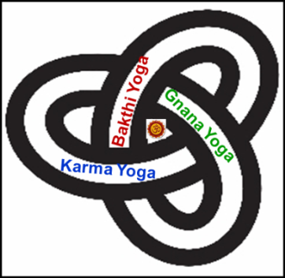
- Center your thoughts that the life giving force in you is the same as that in all of us, in everything and everywhere. There is no conflict between your right hand and the left hand; there is no difference between electricity in a red bulb vs. green bulb, not can any one stop the flow of electricity (or the natural course of the laws of nature).
- With that faith and determination take a look at what you should do. Your duty will be clear. Now proceed as described above (Karma Yoga).
In order to inculcate this capacity cultivate your body and mind – through yoga practices, meditation, worship, prayer, service, volunteering, etc. – that can help you to center your thoughts on the laws of nature or Universe at large. As you see the big picture your duty becomes clarified.
- Gnana Yoga:
There may be a few other times (<1%) when your emotions and questioning mind refuses to accept what your inner self tells you as the right thing you should do even after soul searching and faithful prayers. In those moments resort to analytical reasoning and ask: What is this experience? Why is it this way? Context? Signals or connectors (Knowledge, Ignorance and Bias)? Equilibrium state of these connectors (Tranquility Vs. Turbulence Vs. Ignorance)? Need to rebalance and how? What actions you should pursue (duty) becomes clarified!
Now proceed to engage in your rightful actions!!

Interconnected nature of all pathways:
The entire process looks very complicated. Is that the case? Not really!
Anything in reality is a matter of observation, reflection and then understanding the cause and effect. We practice this in all aspects of life. Practicing the same in any and all activities - for life as a whole - is what is described above!
Practice or not, life will go on – governed by the laws of nature (Brahman)! You have only few choices:
Be the passenger (Arjuna – reflective and raising relevant and logical questions); Be the driver (Krishna – also reflective with relevant answers based on above analytical frame work); or be your true self: passenger and the driver (Arjuna as well as Krishna) engaging all your faculties (Body, Mind and Intellect) to the fullest extent possible!
yatra yogesvarah krshno yatra partho dhanur-dharah I
Tatra srir vijayo bhutir dhruva nitir matir mama II
Wherever there is Krishna, the master of Yoga (Reflective, objective unattached active engagement) , and wherever there is Arjuna (faithful practitioner of Yoga), there will be wealth, victory, power, and fame. That is my opinion with certainty! B.G. 18.78.

Reasoning and faith (Gnana or Bhakthi) are not abstract activities. They have to be carried out only through physical action. Carrying out our activities properly (and appropriately) is called Karma Yoga. Conversely to carry out your duty, one needs to select the right activities! This requires reasoning and faith. These three path ways are not independent. No one pathway is superior or inferior to other just as no one exists only with body and its functions, without emotions and thoughts. Truly they are interdependent and inter-connected. https://sipractce.wordpress.com/2017/01/05/inseprable-nature-of-action-faith-and-reasoning/
Knowledge and understanding (Gnanam) is better than the mere practice of worship. Meditation or contemplation on the basis or meaning of enlightenment while engaged in worship services (Dhyaanam / Bhakthi) is better than mere knowledge. Renouncing the results of actions (Karma Phala Thyaagam) - unattached active participation - is superior to mere meditation as a ritual activity. Through renunciation of self-driven needs one attains peace (Shanthi). B.G. 12.12

Subjectivity Vs. Objectivity
In the above we see an emphasis on “Unattached active engagement (Karma Phala Thyagam). We can also describe this as “Objectivity”. This non-attachment is a true hallmark of any professional!

Let us take any activity. We have defined the context and boundary conditions based on the connectors - Knowledge, Ignorance and Bias. Now we are required to assess the state of equilibrium: Tranquility, Turbulence or Inertia.
This assessment will largely depend on (a) the signals we have acquired through the connectors and (b) our disposition with respect to each of these connectors!
As a professional we exercise great care and attention to the calibration of the sensors, means to connect them to the signal sources, collection, processing of the signal. Equal rigor is applied to the analysis and inferences. This entire methodology is described as “Scientific” that ensures efforts to minimize personal influences or bias of any kind.
Any scientific approach is enhanced when personal connections and opinions (Subjectivity) are removed through distancing from the observations and any factors that could influence the signals. This Objectivity is the non-attachment discussed in philosophy!
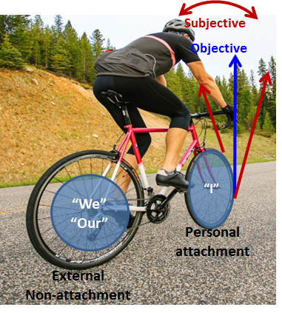
To make it simple, let us consider bicycling as an example. The rider is not attached to his bicycle (body, mind and intellect) permanently. He uses it at will and places the bicycle aside also at will! He has no preference to right or left side of the bicycle. The effort is always to restore the balance and bring the bicycle to the center (without preference to either side – like happiness/sorrow)! Also the emphasis is on applying power (effort) to the rear wheel (external) and not the front wheel to which he is directly attached to and has immediate control (Personal or I). Indeed the rider’s focus is on a location farther away (for larger common good) than on the handle bar and the front wheel (personal needs) close to him. This combination of factors such as maintaining the detachment, balance between the opposites, constant focus on larger goals than near term or personal and self-centered goals as well as the effort to engage and keep others moving, etc. can be collectively identified as objectivity.

Just as bicycling looks formidable in the beginning, objectivity (non-attachment) appears abstract and unachievable when we start with. But through practice (Yoga) objectivity lets us soar to new heights in the joys of life just as an accomplished bicyclist can spin and turn and propel his bicycle at will. Others who see this think of it as a marvelous act!
Set your mind and reasoning (Buddhi) firmly on Me (the Consciousness). There is no doubt you shall become part of Me. ---- Gnana Yoga;
If you are unable to focus your mind, you can reach Me through the practice of constant devotion and worship (of the Consciousness) as the path for enlightenment ---- Bhakthi Yoga;
If you are unable to offer constant devotion, then dedicate your life activities (Karma) – duty - towards Me.
One who conducts his life activities for My cause (true to one’s Conscience) shall reach the state of tranquility (Siddhi) borne out of a resolved (stable and tranquil) mind. ----- Karma Yoga.
If you are unable to do even this, then seek refuge in Me by abandoning the emphasis on the results of all your actions (Sarva Karma Phala Thyagam) --- Objectivity: Practice of Action without attachment: Abyasa Yoga
B.G. 12.8 to 12. 11

The table below shows the stages of engagement in any activity where our approach can be distinguished between Subjective and Objective. This table should be thought of as a trellis that supports a vine (at every level and as needed) and not as a ladder to ascend or descend. Vedanta states that we are all children of immortality. Hence we live with all this knowledge and skills in-built in each of us. It is there for each of us to realize (Self-realization). There are no steps to climb or ladder for ascending and descending!

Subjective Vs. Objective.
Separation between the soul (life giving force) and the physical existence it enables (like the difference between the rider and the bicycle) is clear (YES / NO).
Un-attached active engagement: Corrective actions in place. They are used as needed and at will to manage the balance as well as progress in the journey (YOGA) (YES / NO).
Living in the moment: Prevailing state of equilibrium is duly and faithfully acknowledged, without preference (Sagunathvam) (YES / NO).
Equilibrium states based on the three connectors (Gunathvam) and their relative impact are well understood – Tranquility, Turbulence and Inertial (Sathvikam, Rajasam and Thaamasam) - (YES / NO).
Connectors (Guna) – Knowledge, Ignorance and Bias - and their roles are clear (YES / NO.)
Focus is far ahead (for a larger common purpose) and not self-centered (YOGA) (YES / NO).
Effort is focused on external (other than personal) – on the rear wheel and away from front wheel and handle bar in a bicycle ride - with non-attachment and faith in a larger order! (YES / NO).

Evidences of Objectivity:
    - Enlightened person (Yogi) is restrained on his own accord with a firm sense of purpose, with his/her mind and reasoning set to explore the Laws of Nature (Brahman, God).
    - Friendly and compassionate to all and hates none. Free from self-driven needs and their effects (ego and vanity), such a person is equal in composure in happiness / sorrow; embodiment of kindness and forgiveness.
    - Neither disturbed nor disturbs his/her surrounding; remains free from pride, anger, fear or worry.
    - Seeks nothing (since he has direct control and has restrained his personal needs), pure, versatile / flexible (but rooted in strong principles), impartial or unbiased, free from wants and abandons self-driven motives to initiate any action (Sarva Aarambha Pari Thyaagi).
    - Neither rejoices without limit nor hates; neither seeks association nor grieves any loss; forsakes the good and the bad (Shubha Ashubha Pari Thyaagi).
    - Equal to friend and foe; equal in honor and dishonor; equally at ease in heat and cold, pleasure and pain, free from attachments, equal in response to blame and praise; silent (Mauni); contented with any occurrence; without firm roots or attachments of personal nature of any kind (described as homeless); of firm determination.
    - Indeed, those who pursue these immortal laws or essential rules (Dharma Amrutham) of total self-control and unattached active engagement are My devotees. They are very dear to Me (the Lord) B.G. 12.13 to 20.

From a theological point of view the above may be seen as the desired qualities of a devotee. If we consider God as a metaphor for an ideal person, then the above qualities may be seen as the ideal outcomes or qualities in any of us through the practice of philosophy. Such practice requires non-attachment, relentless exploring the equilibrium states of balance between our knowledge, bias and ignorance (MEAL) and a constant reminder to oneself that any and all in this universe exists enabled by and as evidences of the laws of nature (Brahman): Thath Thwam Asi; Aham Brahma Asmi.

Cognitive Vs. Subtle Universe:
Earlier we have described any person (indeed any object in the Universe) can be seen in one of five inter-connected layers (sheaths): (a) Material / Physical, (b) Living, (c) Emotional with thoughts and feelings, (d) Objective/analytical (e) Governed by Laws of Nature. This fifth layer (Laws of Nature) encompasses and enables all the four earlier layers. This fifth layer is described as blissful existence (Ananda Maya).
The first four layers are cerebral and hence amenable to observations and evidences. We can call them as part of the Cognitive Universe.
We can identify the fifth layer as Subtle Universe. This is the universe of the invisible forces of nature: Brahman (Nirgunathvam). This subtle universe merely exists. We can only recognize its existence through inferences and observations they enable as evidences in the Cognitive Universe!

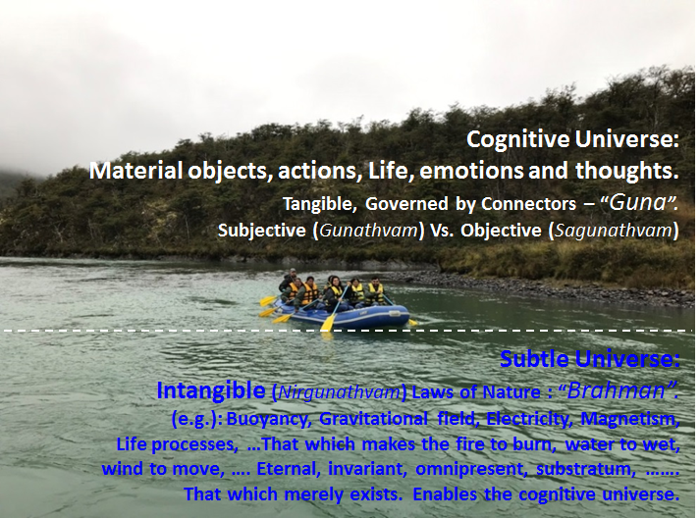
Consider for example the boat floating in a lake. There are people in the boat rowing the boat. The boat, people, paddle, rowing, etc. are all physical. Among these the people are living beings. Each has emotions, experiences, excitement, fear, etc. But, collectively their “experiences” will depend on their subjectivity Vs. objectivity in all their actions. Collectively they have to be objective – maintain a balance – to be sure their weight is balanced and their effort is balanced and properly directed for larger common good (safe passage and a happy boat ride). Yet, all of these cognitive evidences of all that is floating (boat, people, etc.) is enabled by the invisible phenomena of buoyancy! It is one among the many known phenomena of nature at work that enable all that is cognitive. That is the incognitive or subtle universe, co-existing with and enabling all that is cognitive!
There are likely countless phenomena of nature – known and unknown. To the extent we are capable of, we identify the laws through which their evidences can identified, measured, monitored and characterized. We call that as “Science”. The entire body of Incognitive or Subtle Universe is identified in Vedantic Philosophy as “Brahman”.

Session 8 and 9: Nov. 12, 2020 and Nov. 21, 2020.

Vedanta:
We have now arrived at the end of Vedanta or the Vedic Philosophy, which can be summarized as follows:
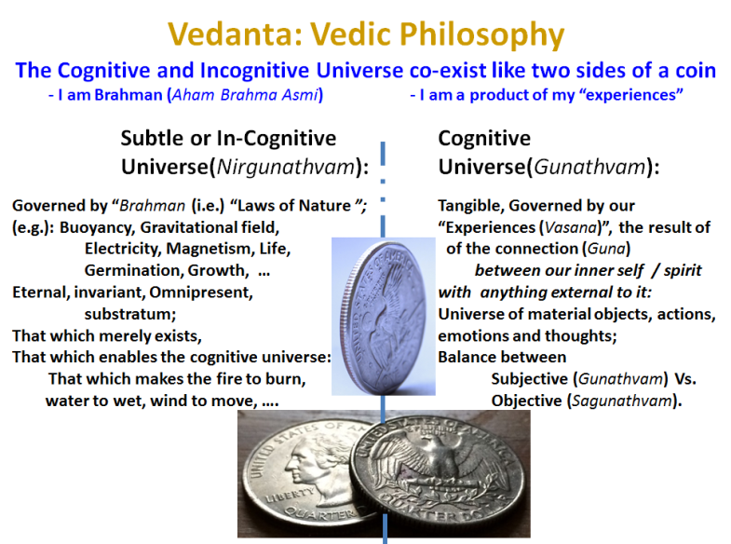
Anything and everything in the Universe can be conceived of having two parallel and co-existing aspects:
The Cognitive and in-cognitive.

They are like two sides of a coin, each side integral part of the other side, inseparable. That is the universe in which we (each of us) and everything we know of as the “Universe“ exist!

The cognitive aspect is clear and obvious. We exist in this universe through our body and its functions, through our sense organs and their roles, through our mind and our intellect. Through our ability to explore and understand all that is around us we also know of the Universe at its outer limit as well as the atom and the sub-atomic particles and the energy field that holds everything together! In this Cognitive universe our thoughts control our feeling and perceptions. These thoughts are the result of three connectors (Knowledge, Bias and Ignorance) and the three equilibrium conditions they create (Tranquility, Turbulence and inertial). These connectors (Guna) and their equilibrium states (Gunathvam) can be managed through a deliberate distinction between “Subjective” (as we see it) Vs. “Objective” (as it can be seen or understood by anyone unattached to the perception, observation, feeling, etc.) outlook. Objectivity is enhanced when our knowledge increases compared to our bias (self-driven attachments) and ignorance. Objective outlook leads to equal regard for any of the three equilibrium states (Sagunathvam).

We can also appreciate the subtle or in-cognitive forces or Laws of nature like gravity, magnetism, electricity, friction, buoyancy, that which makes us alive, etc. This subtle or in-cognitive universe (Nirgunathvam) merely exists. It is omnipresent, eternal, invariant of time, place, people, circumstances, etc. Only at the limit of extreme vanity one can claim we know all of these laws and comprehensively. The quest of humanity over the ages has been to explore and understand these invisible forces of nature which enables all that is cognitive or visible, perceptible, measurable, etc.

This in-cognitive or subtle universe and the Cognitive Universe it enables is together defined as “Brahman” in Vedanta.

The sun does not furnish the light or the moon or the stars; nor these flashes of lightning born of the cloud or the light of the fire during religious services (Yagna). The SELF or Universal Consciousness (Brahman) shines and all else shine as a result. Everything in the universe reflects but That light. Katha Upanishad 2.2.15.

All objects are permeated by Brahman. All actions are possible through the influence or impact of Brahman. Therefore Brahman permeates everything as butter permeates milk.
Brahman is without attributes: neither short nor long; neither subtle nor beyond comprehension; without birth or with changes caused through life cycles; without qualities, color or name.
Brahman illumines the planets that orbit like sun and the moon, but it is not illuminated by any light source other than itself. Pervading the entire universe, outwardly and inwardly, the Brahman (the Supreme or Universal Consciousness) shines by itself.
Brahman is like the heat energy in a ball of iron perceived through the radiation and the red hot glow. Brahman is not limited by the cognitive universe. There exists nothing that is not Brahman
Brahman exists in all that is perceived through our cognitive processes like hearing, vision, etc.
Athma Bodha 59 to 64.

Implications of understanding the Cognitive and Subtle Universe:
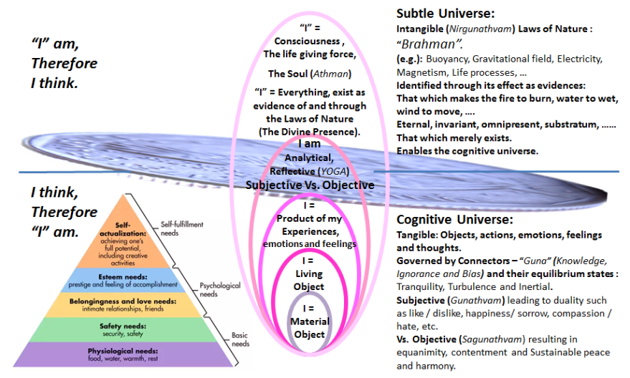
Cognitive universe is based on the connectors of Knowledge, Bias and Ignorance (Gunathvam) and their equilibrium states of Tranquility, Turbulence and Inertial (Sathvikam, Rajasam, Thaamasam). Our perception of the world around us – subjectivity - is governed by these connectors (Gunathvam). Precise identification of the prevailing state of equilibrium requires objectivity (Sagunathvam) fostered by non-attachment and a focus on larger common goal or purpose.

This analytical frame work to manage our thoughts also helps to manage our emotions and feelings, which in turn guide our actions and life towards equanimity, contentment and sustainable peace and harmony.

Western Philosophy Vs. Vedic Philosophy:
This cognitive universe is dealt with in great detail in many ways and schools of thought. “Control your mind, hence your thoughts, observations, feelings and actions” is the guideline from Buddhism. The need to manage our thoughts is also suggested by the French philosopher Des Cartes who states “I think, therefore I am”. Socrates states “I can’t teach anyone anything. I can only make them think”. The entire education and legal process is based on “Socratic Approach”: Ask a question that explores our belief or assumptions (based on bias and ignorance), the answer leads to more questions; this thought process leads to our best understanding or the “knowledge” pertinent to the topic or subject!

In the Western psychology Maslow's hierarchy of needs is a motivational theory comprising a five-tier model of human needs, often depicted as hierarchical levels within a pyramid (See Figure above). https://www.simplypsychology.org/maslow.html Needs lower down in the hierarchy must be satisfied before individuals can attend to needs higher up. From the bottom of the hierarchy upwards, the needs are: physiological, safety, love and belonging, esteem, and self-actualization. These levels parallel the first three sheaths noted in Vedic Philosophy (material, living and emotional) extending into some aspects of the fourth sheath of subjective Vs. objective analytical reasoning and inference (also noted in the figure above). These four layers are part of the Cognitive Universe also identified as the “Material” world. Unlike Maslow’s hierarchy, Vedanta suggests that all four layers of our cognitive existence are co-existent and without any specific hierarchy of needs to be full filled. These four cognitive layers include everyone and everything – all objects - in the universe. Emancipation and integration of anyone or anything with the universe at large – animate / inanimate, rich or poor, isolated or in the company of many, healthy or disabled, etc. – becomes logical when we internalize the co-existing in-cognitive or subtle universe of laws of nature (Brahman). This inclusiveness permits a sense of satisfaction and inner peace for anyone irrespective of their age, education, wealth, health, social standing, etc. It also promotes a harmony with any and all aspects of the universe at large.

Vedic Philosophy and “Science”:
Irrespective of how well or less we comprehend the world around us, we need to keep in mind that everything is enabled by and representations of the effect of the ever present, eternal, invariant and invisible laws of nature (Brahman). Hence the quest in the Cognitive Universe is a relentless search for better learning and understanding of the laws of nature behind our events, situation and circumstances. This quest is also described as “Science”.

Co-existant role of Materialism and Spiritualty:
The incognitive or subtle universe as the enabler of the cognitive would appear unique to Vedic philosophy. Being centered in the Incognitive Universe may also be thought of as being “Spiritual”! Hence Vedanta suggests that being Spiritual and being materialistic are not exclusive of each other. Instead like two sides of a coin they reinforce and add value to each other (i.e.) our life as a whole; add value to any and all material objects as part of the Universe at large!

Our very ability to comprehend anything material, tangible (cognitive) is enabled by the invisible life giving force, an aspect of nature. Brahman or the collective enablers or laws of nature – like a large body of water – merely exists with no known origin or any other tangible properties. Of this a small part – like a droplet of water - acts and it is perceived as the “I” – the life giving force - in me. Hence one could say, “I” am, therefore I think!

On the destruction of the constraints of the cognitive world (body, mind and intellect and their functions and play fields) the enlightened person - saint or Muni – remains totally absorbed in the Universal Consciousness – in the omnipresent: Viswam like water in water; space into space and light into light. Athma Bodha 53.
Because of his true nature – the truth, knowledge and bliss, which are the characteristics of the Self – and endowed with the true knowledge of the Self (Consciousness), the enlightened person gives up the traits of the gross, subtle and the causal bodies (Body, mind and intellect) and transforms like a wasp (which as a worm builds a mud nest and stays confined in it until it emerges as a butterfly with ability to fly – move around without limitation). Athma Bodha 49.

In the following table we find a comparison of Western and Vedic Philosophy. This table is intended only as a quick reference. It is not an exhaustive treatise or even an extensive comparison. Frequently we hear that Western world is “Materialistic” and Eastern world is more philosophic and spiritual. This might be a misguided and partial or biased view. Neither Eastern nor Western thoughts are constrained by materialism or spirituality. In fact both of these exist as two sides of the coin as explained earlier. Vedic philosophy provides a frame work to the two parallel co-existing aspects as Materialistic (Subjective / Objective) and Spiritual (based on the driving force or governing laws). In Sanskrit they are identified as Gunathvam / Sagunathvam and Nirgunathvam.

Western Philosophy |  |  | Vedic Philosophy
René Descartes | “I think, therefore I am” |  | Upanishads | “I am”, therefore I think” – Aham Brahma Asmi.  Everything is governed by Laws of nature – Sarvam Brahma Mayam.  You and the Universe are one and the same – Thath Thwam Asi.
Socrates | I can’t teach anyone anything.  I can only make them think. |  | Upanishads
Maslow’s hierarchy of needs | a five-tier model of human needs:  - Physiological,  - Safety and security,  - Love and belonging,  - Self- Esteem, and  - Self-actualization. |  | Upanishads | Five inter-connected sheaths/ layers:  - Physical,  - Physiological,  - Emotional and Intellectual,  - Reasoning (Objective Vs. Subjective) (Sagunathvam / Gunathvam) and  - In-cognitive enablers (laws of nature / Brahman) (Nirgunathvam).
Philosophy and Theology are generally separate and distinct. |  |  | Baghawath Geetha | Philosophy and Theology are intimately interconnected.

Managing Equilibrium in the activities of daily life: Use of Vedic Philosophy as a practical guide
In the following table we find a list of activities and how they can be looked at for the underlying “connectors”. Persistent and systematic reflection on them to observe the prevailing equilibrium states is the starting point for maintaining and managing equilibrium in all our daily activities:
Features / Activity | Equilibrium States  (Gunathvam)
Features / Activity | Tranquility  (Sathvikam): | Turbulent  (Rajasic): | Inertial / Ignorance (Thaamasic)
- Features | Knowledge and Understanding prevailing over Bias and Ignorance. Measured activities, purposeful with generally satisfactory outcomes for all. | Personal attachments, preference and bias dominant over Knowledge and Ignorance.  Relentless chain of activities with no stability or peace at sight! | Ignorance dominant over Knowledge and bias leading to unrelenting grief, lack of direction and procrastination.
- Reasoning (Buddhi) | Discrimination between: appropriate actions (Pravruthi) that should be pursued and inappropriate activities (Nivruthi) which should be given up;  between fear and fearlessness (Bhaya Abhayaha);  between bondage and liberation B.G. 18.30 | Right and wrong, appropriate and inappropriate, learned through incorrect knowledge and understanding.  Needs, decision or course of action or set of activities seem to be unquestionably appropriate.  However through calm and dispassionate analysis they are found to be correct only in the context of one’s desires, emotional attachments, self-driven needs, etc. B.G. 18.31 | Lack of understanding what so ever, the reasoning or wisdom which leads one to conclude inappropriate activities as appropriate and everything else in reverse order! B.G. 18.32

Features / Activity | Equilibrium States  (Gunathvam)
Features / Activity | Tranquility  (Sathvikam): |  | Turbulent  (Rajasic): | Inertial / Ignorance (Thaamasic)
- Giving gifts (Dhaanam)  Charity, help, …… | Gifts to others as a performance of duties to those who do not have the means to return the favor - as an activity without desire or attachments. Seeks no return - an expression of total self-control and unattached active participation. Giving gifts occurs as a normal course of life, occurring at the proper place, time and to the proper person or need . B.G. 17. 20. |  | Gifts or assistance to others, fully expecting return of such favor (thus being committed to the fruits of their actions). Unwilling and ostentatious acts of charity. B.G. 17. 21 | Acts of charity to the improper recipients, at inappropriate place and time, often in unceremonious manner and with contempt to the concept or process of sharing. B.G. 17. 22
- Happiness (Sukham) | Experience which appears in the beginning like poison, and transforms into nectar in the end, that pleasure of transformation is declared as belonging to tranquil persons. Such HAPPINESS arises out of the purity or clarity of one’s own mind and its power of reasoning within one self. B.G. 18.37 |  | Experience which at the beginning is pleasant like nectar but slowly turns into poison (disliked and in disfavor due to its inability to satisfy the continued and increasing needs arising out of desires). B.G. 18.38 | Pleasure which at the beginning as well as in its continuance is deceitful to one’s own self and leads to delusion, sleep, sloppiness and lack of direction  B.G. 18.39
- Food we consume | Wholesome food, which promotes life, health, vitality and strength. B.G. 17.8. |  | Foods of extreme nature (such as extremely bitter, sour, salty, excessively hot, sharp, of strong odor and taste) leading to pain, sickness and sorrow. B.G. 17.9. | Stale, taste less and unhygienic foods.  B.G. 17.10.
- Prayer Services (Yagna) | As ordained in the scriptures as a duty to be performed without desire for the results (only as appropriate acts in the practice of self-control).  B.G. 17. 11 |  | Ostentatious exhibition of their strength, power and resources, engaged in such ritual acts only with an eye on the results. B.G. 17. 12 | Indiscriminate, without faith and without following the rules and procedures set forth in the scriptures  or any attempt to understands them.  B.G. 17. 13
Austerity (Thapaha) | Actions which are truthful, pleasant and valuable or useful. Soft spoken words; Recitation of the scriptures are also expressions of contemplation on their meaning;  Calm and tranquil mind;  Good natured behavior, Silence (Maunam) arising out of contemplation and introspection leading to self-control (described as pure mind). B.G. 17. 15, 16, 17. |  | Austerity to gain personal gains of respect, honor and welcome (Sath Kaaram). Pretend to pursue austerity as a means of self-control. Such behavior is described as hypocrisy, unstable and only of transitory value.  B.G. 17. 18. | The performance of austerity through torturing oneself and leading to harm for others;  foolish, obstinacy and ignorant of the path of enlightened living.  B.G. 17. 19.
Features / Activity | Equilibrium States  (Gunathvam)
Features / Activity | Tranquility  (Sathvikam): | Turbulent  (Rajasic): |  | Inertial / Ignorance (Thaamasic)
- Activity (Karma) | Activities appropriate to be performed; which is carried out by a person who seeks no results from such activity; which is carried out without attachments to “pairs” such as love/hate, happiness /sorrow, etc. B.G. 18. 23 | Activities carried out to meet one’s desires and with a need to full fill personal or self-driven preferences (Sva Ahankarena Karma) (also described as self-conceit or ego), even though carried out with great deal of effort or labor (Bahu Aayaasam)  B.G. 18. 24. |  | Activities undertaken for reasons of uncontrolled desires (Moham) without any consideration to the effects or consequences, loss, injury or harm and capability. B.G. 18. 25.
- CONSISTENCY (Dhruthi) | Consistency With which one controls the mind, the breathing or life processes, activities of the body organs and in the pursuit of the path of enlightenment (Yoga)  B.G. 18. 33 | Consistency in the performance of one’s actions for reasons of desire or wealth with attachments to the fruits of all such activities. B.G. 18. 34 |  | Foolish dependency through which one constantly falls back to sleep, fear, grief, dejection and passion B.G. 18. 35
- Ethics
- Morality
- Forgiving
- Seeking forgiveness
- Ego
- Education
- Research
- Job
- Career
- Family life
- Relationship

Session 10: Nov. 26, 2020.
Philosophy, Theology and Science:
Earlier we described the Universe as a coin with its two sides: The world of activities and everything that we can relate to as the Universe is one side, the Cognitive. All laws of nature which enable all our activities and the Universe at large is the other side of the coin. They are subtle. They can only be inferred through their effects. This in-cognitive or subtle and the cognitive side co-exist. The cognitive being the enabled and the in-cognitive the enabler.
The Cognitive is readily understood as our body, mind, organs, its functions, our world of activities, objects, mountains, ocean, space, planets, cosmos, etc.
The in-cognitive or subtle requires a little bit of thinking and inference. What enables the wind to move? Fire to burn? Seeds to grow? Our growth from fetus to baby to a person to old age? What is it whose absence makes my body dead and hence inert? What makes the stone to sink and the leaf to float? What is gravity? Electricity? Magnetism? To all these questions if we keep answering “Na iti – It is not this”, we come to a place where we have to accept one of two answers: It is the way it is or it is the law of nature. Vedanta gives a single term “Brahman” for either of these answers!

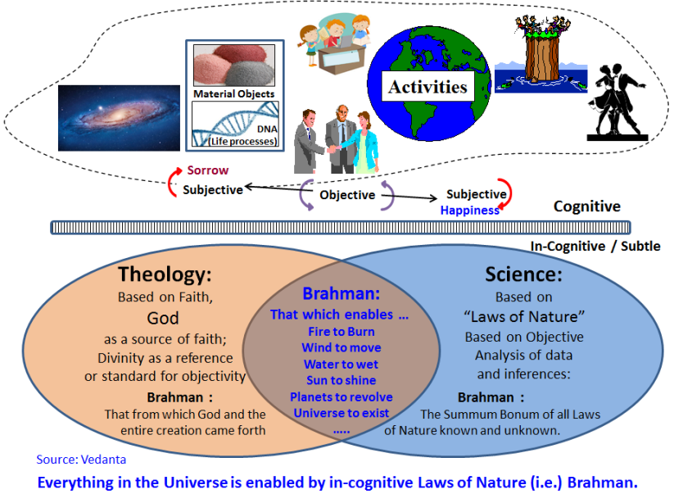
During meditation we practice “It is not this” mindset as follows: Recognize every part of your body from the tip of your toes, all the way to the top of your skull. Every one of them is part of you. Every one of the parts is active and alive through our respiration, blood circulation, neural response, etc. Evidences of each of these vital functions can be seen at every part of the body. What enables these vital functions? We can explain them through physics, chemistry, biology, biochemistry, etc. which are common for all living objects. Where do the governing rules or principles of these scientific disciplines come from? They merely exist. This collection of all laws of nature, known and unknown are described as “Brahman” in Vedic philosophy. One can accept the abstraction as Brahman.
One can also accept the abstraction as the enabler created God and from God everything else was created. This belief system is called “Theology”. It is the basis for all religions.
One can also accept the abstraction and explore it in limited context to better understand our observations and evidences in the Cognitive Universe. This is the basis of Science in any field of study. This description of the Cognitive and In-cognitive universe is illustrated in the figures above. The in-cognitive universe understood as an abstraction (without properties – Nirgunathvam) or Brahman, perceived through Theology or Science is also illustrated in the figure above.

Brahman: Kenopanishad
The following verses and a story from Kena Upanishad further illustrate the definition of “Brahman”: that which enables the fire to burn, wind to move, etc. The word “Kena” in the title stands for “enabled by whom” is this Universe created?

Secion1:
Willed or impelled by “What” does the mind get directed, to seek or go after an object? . “What” is the primal force that is behind all the activities? Through the will or intention of “What” are these words being spoken? “What” enables our vision and our hearing? Kenopanishad 1.1.
It is the enabler of the hearing by the ears, the thinking by the mind, the speech through what is spoken, the life in the living, vision in the eye. By giving up the self-identification with the organs and their actions and becoming united with the enabler of all their functions, the wise men become immortal. 1.2.
We cannot teach or instruct about this primal force, because we cannot reach it through the eyes, the speech, through knowledge or reasoning. 1.3.
It is different from all that is “Known”. It is above the known. This is the knowledge handed down to us by the ancient teachers, who have explained It to us. 1.4.
It is that which is not explained by speech, but that which enables the speech.
It is not that which is comprehensible to the mind, but which enables “comprehension” by the mind. It is not that which is seen by the eye, but which enables the vision through the eye.
It is not that which is heard through the ears, but which enables the hearing through the ears.
It is not that which is smelled, but which enables the smelling by the nose. 1.5 to 1.9.
Each of the above verse ends with the phrase “recognize that as Brahman, not the objects that are worshipped” providing the rhythm and poetic grace. The phrase also separates blind allegiance to theology from reasoning centered philosophy.

Section 2:

In this section, the teacher urges the student to reflect on the above teachings. The student explains the subtle aspects of Brahman and its existence as the substratum of all forms of existence. It is the attempt by the student to rephrase the teachings in a manner that he has understood.

Teacher: If you think that you have understood “Brahman”, sufficiently, you have merely understood Brahman as It relates to human functions and the little as It relates to the Gods. Hence Brahman needs to be deliberated upon by you.
Student: I think “Brahman” is known to me.
“I do not think that I know Brahman, well enough. Not that I do not know, yet I do not know well enough. Those among us, who understands the statement: “Not that I do not know, I do, but I do not know well enough” knows that Brahman”
Brahman is known to those who know it as Unknown. Brahman is not known to those who know It well. It is unknown to those who know it well and known to those who do not know the Brahman well enough.
The Brahman is known through the Self, as the agent of consciousness. Through such knowledge one acquires immortality. Strength is acquired through the knowledge of the Self, and through such Knowledge one acquires immortality.
If one has realized this Knowledge of the Self as explained here, realizes the Truth (That the Self is the abode of Brahman). For one who has not realized this Truth, there is great destruction (due to the effect of the duality of pleasure/pain, etc.). The wise one having realized the Brahman as the substratum of the Self, in all beings, hence having turned away from the world (of cognitive aspects) becomes immortal. Kenopanishad 2.1 to 2.5.

Section 3
After a hard fought battle and the victory, the Gods became elated. They thought, "This victory is ours. This glory is ours". Brahman perceived this and appeared before them. They did not know what mysterious form it was.
Gods said to Fire: "All knowing Fire God (Agni), Find out what mysterious spirit this is?" Agni ran forward and Brahman said to him: "Who art thou?" "I am Agni (the Fire-God)”, he replied.
Brahman asked: "What power resides in thee?" Agni replied: "I can burn up all whatsoever exists on my path." Brahman placed a straw before him and said: "Burn this." Agni rushed towards it with all speed, but was not able to burn it. Agni returned from there and said to the Gods: "I was not able to find out what this great mystery is."
Then they said to Vayu (the God of wind): "Vayu! Find out what this mystery is?" Vayu ran forward and Brahman said to him: "Who art thou?" "I am Vayu, traveler of Heaven," Vayu said. Brahman asked: "What power is in thee?" Vayu replied: "I can blow away all whatsoever exists on my path." Brahman placed a straw before him and said: "Blow this away." Vayu rushed towards it with all speed, but was not able to blow it away. Vayu returned from there and said to the Gods: "I was not able to find out what this great mystery is."
Then they said to Indra (the king of all Gods): "O Worshipful One! Find out what this mystery is?" As Indra ran forward, Brahman disappeared. Then Indra saw in that very space a woman beautifully adorned, Goddess Uma of golden hue, daughter of Himalaya Mountain, wife of Lord Siva. Indra asked: "What is this great mystery?"

Section 4:
Goddess Parvathi also known as Uma said: "It is Brahman. It is through the victory of Brahman that you are victorious." Then from her words, Indra knew that the mysterious form was Brahman.
Uma continued "It is to Brahman that you owe your victory. It is through His power that you live and act. He is the agent and you are all only instruments in His hands. Therefore your idea that 'This victory is ours, this glory is ours,' is based on ignorance." At once Indra saw the mistake. The Devas, due to their vanity (ego), had thought they themselves had achieved the victory, whereas it was Brahman; for not even a blade of grass can move without His command.
These Gods--Agni, Vayu and Indra -- excel among other Gods, because they came closer to Brahman in that they were the first to know of Brahman as the enabler.
These are the instructions of the mysterious Brahman (the venerable one):
The Brahman is the flash or illumination in the lightning; It is the winking of the eye.
That which is known, that which is perceived by the mind, the process of repeated reflection by the mind, the thought itself are all Brahman.
The Brahman is well known as the “Adorable one to all creatures” (Tadvana). Brahman is to be meditated upon by this name.
These analogies refer to a wide variety of events and occurrences all around: the flash of lightning (an extra-terrestrial event) or winking of an eye (an ordinary basic activity of any and all living beings).

Student: “Sir, Please teach us the secret knowledge of the Brahman”.
Teacher: “I have already taught you the very secret knowledge of Brahman”.
Concentration, Cessation of the world of duality, performance of one’s duties (rites) are It’s legs. The Vedas are its limbs; Truth is its abode (or residence). Anyone who knows this in this manner, having dispelled their ignorance, remain firmly seated in the boundless, blissful, and the highest – the Brahman. Such a person of knowledge and understanding remains firmly in union with Brahman.

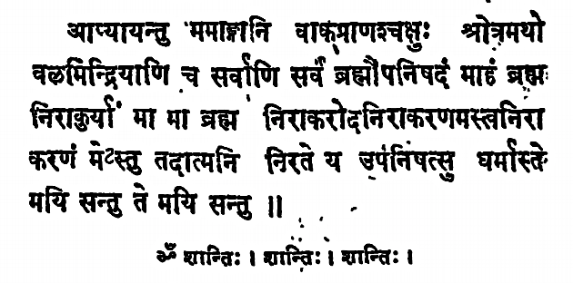
May my limbs, Speech, breathing, eyes, ears, strength and also all other organs, become well developed. Everything is Brahman revealed in the Upanishads. May I not deny Brahman, May Brahman not deny me. May I not reject Brahman. May Brahman not reject me.
May all the virtues spoken in the Upanishads rest in me, who is engaged in the pursuit of the Knowledge of the Self. May such tranquility become part of me. Peace! Peace! Peace!

In Hindu theology Brahman the invisible, eternal and omnipresent is believed to be the source from which the Gods emerged. If objectivity is the goal in the Cognitive side of the Universe, in theology Gods are accepted as embodiment of the highest level of objectivity. In practical terms anyone who acquires greater objectivity and ultimately reaches its higher pinnacles can be seen as the leader with divine qualities.
Searching for the invisible laws of nature is also the foundation of any “scientific” endeavor. Higher the objectivity, greater our ability to seek out and find the common driving force – laws of nature – behind the phenomena under study. Thus we can see Theology and Science merely as dual representations of the Brahman, the foundation of the in-cognitive side and enabler of the Cognitive aspects of the universe (See Figure above). Theology and Science are parallel pursuits. They are not in conflict with each other. “Science” is rooted in analytical reasoning. It requires objectivity of highest order. But any scientific pursuit is carried out by human beings who are always conditioned by their emotions and feelings. Theology is based on the unalterable faith in God. In any activity or in dimension of our thought, God is the ideal for objectivity. Unrelenting objectivity reflects as the divinity or presence of God in our actions. It provides emotional stability and an ideal to seek towards objectivity. Hence theology enhances the objectivity in the analytical pursuit of scientific studies by anyone. This complimentary role of science and theology may be described as Gnana Yoga and Bhakthi Yoga respectively. Both these pathways are implemented in real life actions through action or Karma Yoga! (See discussion on the interconnected role of these three pathways in an earlier section).

Two aspects of Yoga: Union with the self:

Yoga: Dwell in the single thought that everything in the universe is enabled by the in-cognitive (i.e.) Brahman through the laws of nature.
Our life even when it is full of activities, most of the time runs on its own, as if it is on auto pilot! But we fail to recognize this smooth running of many aspects of life simply because of our occupation or pre-occupation with a few events that garner our attention. Hence we fail to recognize the laws of nature (Brahman) at work in so many ways. Instead we see our life as a struggle only based on a few thoughts that occupy our mind. The material aspects of our activities are reasonably clear and obvious. A sugar cube is sweet and melts in our mouth. A crystal, even if it appears as a sugar cube is hard and dense. We can recognize the sugar cube as well as the hard crystal instantly. Yet, on occasion we bite into a hard crystal imagining it as the sweet sugar cube, and then feel miserable with the pain! Such instances of failure in our perception, judgement and emotions are far fewer than the totality of the activities identified as “life”. It is necessary to isolate those few thoughts that occupy our mind in the cognitive side and not become overwhelmed by them.

Cognitive universe is enabled by countless activities. But any and all activities are governed by relevant laws of nature, the collection we identify as Brahman. We are engaged in countless activities like the waves on the surface of the ocean. We need to maintain a persistent thought that all activities of life that come to our attention are merely like the waves on the surface of the deep ocean. This brings about a permanent calmness and tranquility as the deep ocean (which is unaffected by the surface waves) is one aspect of Yoga or union with the self (Brahman – the enabler).
Yoga: Dwell in the single thought that everything in the universe is enabled by the in-cognitive laws of Nature (i.e.) Brahman.

Yoga: Control your mind and hence your thoughts, observations, feeling and actions.
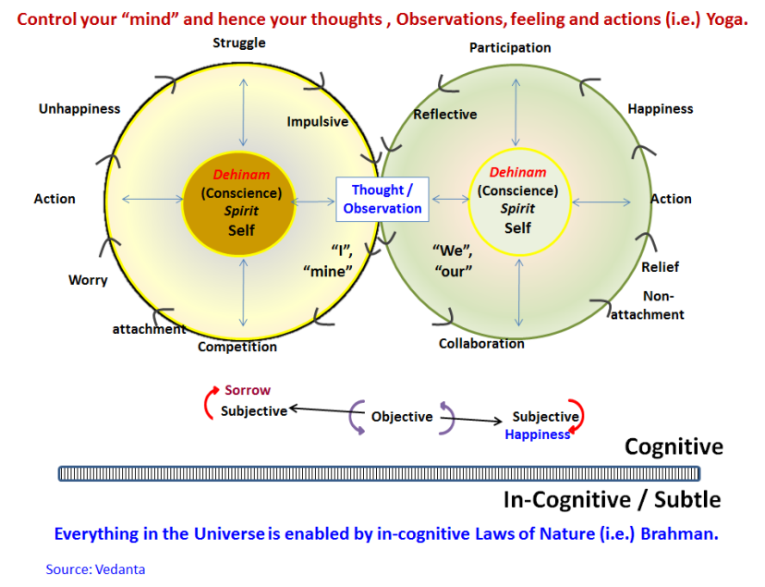
Among the countless activities that make up our life, very few among them engage our attention through our thoughts. Managing these few thoughts and the actions that follow is another aspect of the union with the self or “Yoga”. Each thought can be traced to one of two cyclic paths as illustrated in the figure. Through our attachments these thoughts can be focused on “I” and “mine” such as my wants, my needs, my desires, etc. This attachment leads to competition and worry. It also results in initiating a set of actions and their results. Unable to meet my wants and needs I struggle with unhappiness leading to next impulsive thought. There is a parallel path for my initial thought where the purpose or focus could be beyond myself (i.e.) focused towards others or we and ours. In this cycle we see collaboration. The non-attachment leads to a sense of relief. The resulting action leads to happiness, participation and a reflective mindset towards the next thought!
This management of our thoughts and actions if it is through non-attachment and hence external focused for a larger common good, it becomes more objective with tranquility as the end result. If our thought is driven by attachments driven by unbridled personal attachments and needs or lack of reflection (as a biased and/or ignorant approach) it becomes more subjective with turbulence and grief are the outcome. This balancing of Objective Vs. Subjective has been already discussed extensively. This balancing act is also dealt with in great detail in every religion. We also see many studies and countless books on self-development to deal with this balance.
Yoga: Control your mind and hence your thoughts, observations, feeling and actions.

What is “Ego?” or self-centered nature?
Two principles of Vedanta cover the vast body of knowledge like two book ends:
- Everything in the universe is enabled by invisible laws of nature (Brahman), which become visible only through their effects. Keep your mind tranquil like the deep ocean focused on that Brahman, the enabler or the substratum of everything.
- Through non-attachment and objectivity control and manage the thoughts that occupy your mind and hence your observations, feeling and actions.
With the above two principles at work any person (Yogi – practitioner of internal or self-reflection) remains calm and tranquil as his/her foundation with objectivity in management of any activity as a natural course of action. This is the MEAL (Maintaining / Managing Equilibrium in any and all our Activities and Life) described in Vedanta.

If we show allegiance to these principles the notion of “I” independent of the laws of nature or objectivity does not arise. This manner of living or engaging in any activity is described as spiritual (rooted in the spirit or soul or life giving force) or enlightened living. Absent that any approach that suggests that “I am the doer” or “I am responsible for this action or outcome” suggests attachment or self-centered perspective. This approach or perspective is to be understood as “ego”.

Any person who is free from self-centered perceptions (free from ego) and of untainted reasoning (objectivity) remains unaffected by any activity and its effects B.G. 18. 17

Any activity appropriate for the moment carried out with total self-control (evidenced by objective or dispassionate reasoning and absence of self-centered perceptions) leaves no effect on the person, who participates in that activity. In Baghawath Geetha, this manner of participation in life is presented by Lord Krishna to Arjuna, who is in the middle of a battle field facing his opponents. Krishna states “let your participation be enlightened in nature, even though you believe that you are in the middle of a crisis and you are responsible for your actions. Such enlightened participation will leave no effect on you”.

Sometimes the term “non-attachment” is not well understood. Non-attachment does not imply a casual attitude for the activity or the purpose for it. Instead think of any activity like driving a car or a bicycle. As long as there is a need to drive the car, you (the driver) and the car are intimately connected. But the driver can walk away from the car or bicycle at any moment as needed (non-attachment). Can you maintain such mental and emotional separation from your job, project, relationship or any activity you are engaged in? You can do so when you truly believe that you are merely an agent, part of the means through which the invisible forces of nature (Brahman) is at play! You can also maintain such separation since your goal is focused on a larger common good and your reasoning is objective (dispassionate with equal regard for all inputs). Hence we can see “non-attachment” represents absence of ego.

“Professional” as a practicing philosopher
When we accept that anything and everything is enabled by the invisible forces of nature (Brahman), It is obvious that “everything” includes each of us. We merely exist! Whether we understand and/or explore the prevailing laws of nature that is merely a choice. Some choose to explore these laws in specific areas or field of activity. We call them as “Scientists”. Few among them extend this knowledge to deliberately apply such scientific knowledge to develop solutions of use and value to others. They are called as “Engineers”, “health care professionals”, “Lawyers”, etc. Some of them also facilitate the focus area and methodology in the pursuit of these activities. They are identified as “managers”. All of them are engaged in analytical reasoning in one way or another. They are all identified as “Professionals”. Science, Engineering and Management are merely the tools of any professional! The professional also has a purpose in mind (solution) and tasks are his/her means to that end. This system thinking of a professional is aided by a collection of Transformational Skills. For details please see: https://stimsinstitute.com/20151207books/

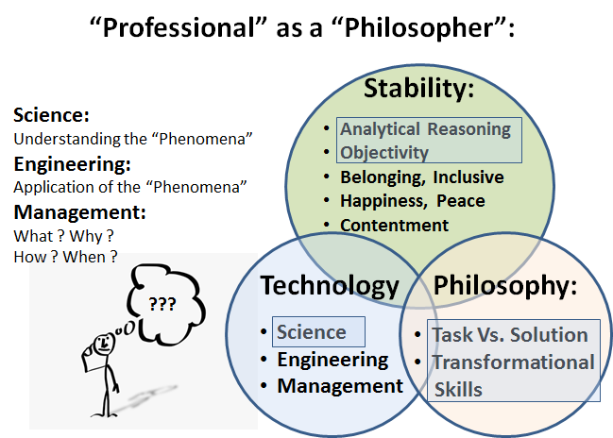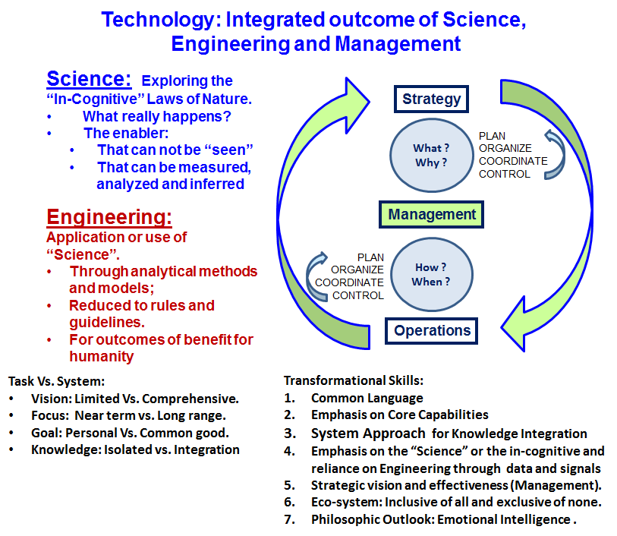

What we have discussed until now is applicable in the life of every person. Everyone seeks stability in his/her life which includes a sense of belonging, happiness, peace and contentment. Professional engages analytical reasoning and objectivity deliberately and as a choice. He/she does not rely on them as chance events. It is part of a cultivated habit. Through their analytical reasoning and objectivity, which brings a true practice of non-attachment, every professional gradually transforms into a practicing philosopher. Additional details on Science, Engineering, Management, Task Vs. System and the Transformational Skills can be seen in the figures above and the books in the link referenced above.

In the above discussion we have taken the liberty to treat “Engineering” in a broad sense. For simplicity it stands for “applied Science” applicable to any profession. This is not meant in any way to elevate engineers above countless other professionals such as doctors, healthcare professionals, artists, actors or musicians. Description of professional as a practicing philosopher applies to any professional field. Highest level of objectivity and non-attachment is noted among the best doctors, health care providers and social workers.

Session 11: Dec. 3, 2020

Managing Equilibrium in Life as a whole:
Let us now consider life as a whole instead of treating it merely as a collection of activities and the experiences from them. We can conceive of three dimensions to any person’s life:
- Economic (Physical),
- Social (Emotional) and
- Spiritual (Intellectual).

One can think of these dimensions of life as interacting spheres influencing each other. One may also think of life as a three legged stool, each leg representing one of these three dimensions.

Physical aspects of life pertain to food, clothing and shelter, which are the common need for anyone. In Maslow’s hierarchy of needs the physical and social dimensions occupy the bottom of the hierarchy of needs: physiological, safety, love and belonging and esteem ending up with Self-actualization. In such motivational theory “Self-actualization” is described as the psychological process aimed at maximizing the use of a person’s abilities and resources.

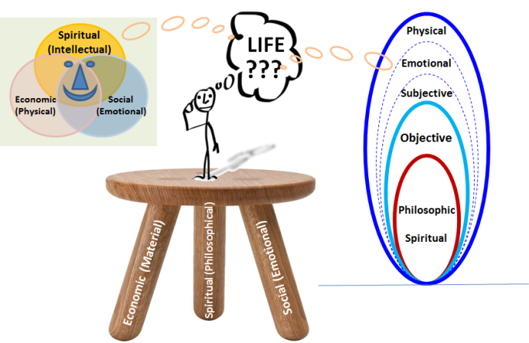
The third or the Spiritual dimension of life described in Vedanta goes beyond Self-actualization. Instead Vedanta considers the highest dimension in human life as “Self-realization”. This implies the understanding that “I” as a person is both the visible embodiment (through my body, mind and intellect) and the invisible enabler (Brahman) the life giving force or the spirit. This spirit or soul in each of us is recognized as a droplet of water (Jeeva Athman) indistinguishable from the Universal Consciousness (Parama Athman) analogous to the bucket of water or any large body of water. This realization that each of us and everything in the universe including the economic and emotional dimensions and yes, even self-realization is enabled by Brahman is the overarching frame work of Vedic Philosophy. This role of Brahman merely exists and enables the entirety of life and Universe as a whole is a profound concept, which can only be understood. It cannot be sufficiently explained by anyone other than the self.
Those among us, who understands the statement: “Not that I do not know, I do, but I do not know well enough” knows that Brahman”. Kenopanishad section 2

All of us know the laws of nature to some extent like the vision through our eyes, hearing through our ears, etc. We also know gravity and magnetism and electricity through many examples of their use and experiences of life. Hence we could say “Not that I do not know, I do”. But even the best among us is always learning something new about the laws of nature. Certainly there are so much more to learn and understand that it is beyond anyone in his/her life time. Hence to say “but I do not know well enough” is very proper and consistent with a true understanding of the universal, omnipresent and eternal aspects of the laws of nature identified as Brahman.

Managing life is not merely a collection of economic or material activities and our competence and preparation for that. Life is also not limited to emotional wellbeing and managing that through our understanding of the connectors (Guna: Knowledge, Ignorance and Bias) at any time as needed and the equilibrium states they create. While these two are essential, along with them is a need for the third dimension (i.e.) Spiritual, rooted in the thought and understanding of the Brahman (i.e.) the laws of nature, the life giving force, the enabler whose action we remain as the witness in the material and emotional spheres.

The four pillars of life (PurushaArtha):
Dharma, Artha, Kama and Moksha are described as the four pillars of Hindu life (based on Vedic philosophy).
Dharma or righteousness is considered as the duty one is required to pursue or perform. This begs the question: What is the duty? If we accept that everything is enabled by the laws of nature (Brahman) then it is the duty of the apple released from its branch to fall down. It is the duty of polished silver to tarnish (oxidize) when left in the open air. It is the duty of a raw mango to ripen and ultimately be consumed or rendered useless by fungus when left unprotected or perish in the soil where it fell down. It is the duty of the fetus after conception to grow into a child and be delivered as a baby at the right time. It is the duty of the fish to live in the ocean or die when it is left on the dry sand in the beach. …..Hence Dharma or duty as evidence of laws of nature are clear and obvious.
Yet, when it comes to us as individuals we are torn apart unable to decide “what is my duty?”, “What should I do?” These confusions disappear if we are dispassionate (non-attached), objective (externally focused on larger common purpose) and treat all evidences of knowledge, bias and ignorance with equal weightage (Sagunathvam)). This non-attachment and reflection / reasoning is called Yoga. The outcome of such analysis brings us as close as possible to determine what is the likely action consistent with the prevailing state of affairs (i.e.) the possible laws of nature at work? This leads to the proper course of action, the duty or Dharma.

Artha or means that enable the tangible aspects of life. This includes our body, mind and intellect. It also includes everything that contributes to our physical and emotional dimensions of life. Artha also defines the context with respect to any activity, situation or circumstance.
There are five aspects necessary for the culmination of any activity. The source or reason for the action (Adhishtaanam); the person involved (Karthaa); the means, tools or equipment (Kaaranam); the effects or outcome (Cheshtathaha) and the forces of nature or the divine influence (Dhaivim). Whatever activity a person carries out - proper or otherwise - these are the five aspects (Artha) of all such activities. This being the case, anyone who believes - due to his/her limited reasoning - that he/she is solely responsible for that activity (Athmanaam Karthaaram), does not see the full picture. B.G. 18. 13 to 16.
Sources or nuclei for all actions are the knowledge (Gyanam), understanding (Gyeyam) and the person possessed with such knowledge (Parigyathaa). Every action is the culmination or union of these three (Karma Sangrahaha) through the instruments or tools of action (Kaaranam), the activity itself (Karma) and the person involved in the activity (Karthaa). B.G. 18. 18

Kama or attachment with which we get connected to the means or objects of life. This attachment limits our ability to separate the essential activities, the duty or Dharma vs. non-essential activities.
It would appear that “attachment” is a cultivated habit. After all, I should want to get attached to something: any object, feelings, person, etc. But if we reflect upon we find that “attachment” is more natural and “non-attachment” is a cultivated habit! This contradiction or dichotomy is described as illusion (Maya) in Vedic literature. See later section on Maya.
From the very beginning, from the childhood we are identified by our name, our parents, family, what belongs to me, my toys, my accomplishments, my identifications, me, mine, …… All of these over time define our thought process. As a result attachment (Kama) to anything and everything is natural! Even after the death the person is identified as someone whose soul passes on to the next birth and cycles of birth, …. Even after death there are worries about my good and bad actions (Papa and Punya) and their impact on the life of the surviving members of the family. Hence the connection or attachment also continues!
It requires reflection to realize that I am just another object in the universe. My name is just one among the name of millions if not billions of others on this planet; each one has his/her parents, family. What belongs to me is nothing more than a small fraction of all that exists on the earth and indeed in the universe. My accomplishments are merely outcome of activities of which I was part of along with many others, in the context and circumstances and the laws of nature that influenced the results or outcome. You get the point. Non-attachment is natural for all objects and other species which merely exist governed by the laws of nature. Endowed with the ability to think and reflect, non-attachment is a cultivated outcome for us human beings, even though we also exist enabled by and as evidence of the laws of nature (Brahman). This need for cultivate habit for non-attachment can be seen in hundreds of writings in Indian literarature, mostly in the form of prayer songs. As an example: https://sipractce.wordpress.com/2020/01/30/brahmam-okate-everything-is-part-of-nature/
There are no differences of low and high. Lord (the soul inside all of us, the driving force behind everything) is one and the same.
Every form of creation is one and the same because the indwelling spirit in every creature is one and the same.
Be it a King or a Slave, everyone has to sleep. Be it a noble man or uncultured rude person, the earth they stand on or lie down to sleep is one and the same.
The sensual pleasure is one and the same for angels or for the insects and animals.
The day and night are equal in duration to the rich as well as the poor.
One could afford to eat tasty food and the other eats stale and wasted food. But the tongue and the sensory perception of taste is the same for both.
A fragrant object or one of bad odor, the air that carries the smell is one and the same. Be it an elephant or a dog, the sun shines alike on both of them.
The Lord who sits in judgement of the good (Punya) as well as the bad deeds or the sin (Papa) is one and the same.
The law of nature (Brahman) is the same even if see its effect as benevolent or violent.

Moksha or liberation is the fourth pillar of life. It is the true comprehension of the Brahman as the substratum and enabler of everything known and unknown. Liberation is not merely non-attachment. Nor does it imply a stage in the after-life. See the section later on renunciation Vs. liberation.

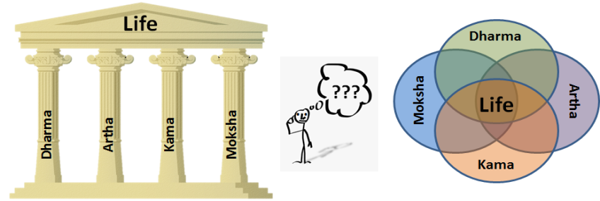
Vedic philosophy suggests that anything in the universe follows the action (Dharma) ordained by the laws of nature through the means (Artha) pertinent to the situation with non-attachment (or engagement precisely as required) leading to the liberation. The end result is the invariable and visible evidence of Brahman (laws of nature) at work. It is the Dharma of the wind to blow and create the breeze. If the breeze passes through a flower (Artha) it picks up the pollen and the fragrance is spread. We say “the breeze spreads the fragrance” as an expression of our like or attachment (Kama). The wind, the breeze, flower and fragrance merely exist liberated (Moksha) of their role and effect.

In all our activities and in life as a whole it is possible to engage with true objectivity and non-attachment. The resultant action – duty – is what one is required to do, given the situation and circumstances. This manner of engagement in life is “liberation”. Such liberation can be here and now!

Four stages in life:
Brahmacharyam, Grahastham, Vanaprastham and Sanyasam are described as four stages of growth in life in Vedic literature.
Brahmacharyam: This is a period of formal early education during which, the student acquires both spiritual and practical knowledge. Traditionally the student leaves his home to stay with a teacher (guru) with two duties: learn the skills for his life and practice unwavering devotion to his teachers. During this period, he is called a Brahmachari (practitioner of celibacy) as he prepares for his future profession, as well as for his family, and social and religious life ahead.
Grahastham: This stage literally means “householder”. At this stage, the lessons learned earlier are put to use pursuant to the four pillars of Dharma, ​Artha, Kama and seeking liberation (Moksha). Traditionally this stage is considered to last until well past middle age.
Vanaprastham: This is the stage of gradual withdrawal (literally means progression towards the forest!) The householder’s duty as a member of the family comes to an end. At this stage, he should renounce all physical, material, and sensory pleasures, retire from his social and professional life and leave his home for a forest hut where he can spend his time in prayers, maintain little contact with the larger family. The societal role for the third stage is to serve as elders and counsel members of the community at large, teaching dharma to those who visit.
Sanyasam: This is the stage of renunciation and complete or total Self-realization. At this stage, a person is supposed to be totally devoted to God. A sanyasi has no home, no other possessions or belonging; he has renounced all desires, fears, hopes, duties, and responsibilities. He is virtually merged with God, all his worldly ties are broken, and his sole concern becomes attaining moksha or release from the circle of birth and death.

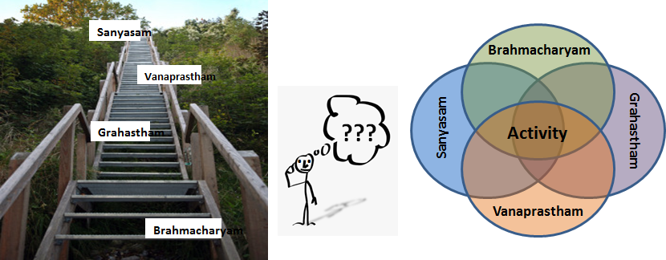
Since this document is focused on Philosophy (i.e.) rigorous analytical reasoning with a love for wisdom, let us take a critical look at the above four stages of life. Their non-traditional descriptions can fit well with our philosophic understanding of Vedanta. Such interpretation may also be well suited for their application or use in our modern day life.

Brahma Charyam in Sanskrit translates to “Seeking out Brahman” or “pursuit in the path for Brahman”.
Any activity, task, project, problem to be solved, etc. begins with an objective analysis of the context or background, what is already known, what needs to be known and how all of these provide clues for the possible underlying principles, laws of nature (Brahman). Perhaps it would be more appropriate to consider Brahma Charyam as the first stage of any activity or task, its understanding and formulation? Objectivity (progression towards Sagunathvam) and implicit faith and belief in the feasible laws of nature (Brahman) are important tools at this stage of learning as well as every following stage. Thus Bramacharyam could be the first or initial step at any time, for any activity and at any stage in life.

Grahastham: Once the problem or task on hand is understood and the prevailing rules or laws become clear, then it is a matter of applying our understanding or practice. This will require reliance on Dharma (execution of duty or what is clearly understood as the proper course of action), Artha or the means or context of our engagement, Kama or the invariant attachment that hold us together in the world and circumstances we live and the subjectivity as a result and Moksha or liberation which requires objectivity and unattached active engagement. Viewed from this perspective “Grahastham” could merely stand for enlightened engagement at any time and in any activity, irrespective of the age, stage in life, etc. Traditional view of “Grahastham” refers to a married person and his/her family life. Instead we can see “Grahastham” merely as the life of the practitioner of Vedanta. It acquires a universal significance relevant to anyone.

Similarly we can understand “Vanaprastham” in a larger and broader context. There is an implicit expectation of non-attachment in engagement in any activity with due respect to Dharma (right Vs. wrong, how and why, based on objective reasoning). Perhaps this withdrawal from personal attachment or retreat that enables objectivity could be the Vanaprastham suggested in Vedanta? Perhaps it need not be a separate stage in life to occur only after midlife or in the middle of a forest?

Sanyasam or renunciation need not be seen only as the last stage in the life of any person. Any activity or endeavor can start with the learning phase, engagement with due reverence to objectivity and the prevailing context and laws of nature (Brahman), non-attachment or objective engagement and observe the course of action. If these three stages of any activity are faithfully executed the end result will be a state of mind that is not attached to the previous actions or seeks out any new actions. Instead the next action is merely the one as required by the situation and circumstances of life at that time. Could this state of renunciation be “Sanyasam”?

These four stages of life can repeat as often as we engage in activities through the entire course of life. But irrespective of the activity, age, time period in life and circumstances, the approach remains the same: Learning, Engagement, Withdrawal that promotes objectivity and renunciation. At any time and in all these stages and at all times the person is constantly reflective of the self (Spirit, soul, life giving force, enabler, Brahman) and its engagement with everything external to it. This awareness of the self as something other than the cognitive universe creates the non-attachment or liberation. Perhaps this is the “Self-realization” and the spiritual way of life described in Vedanta?

Above description of the stages of life is not intended to be revolutionary or counter to the traditional views. In fact the traditional views of Grahastham only as a family man or Sanyasi as a person with minimum of clothes and possessions and in certain attire limits our ability to understand and apply Vedanta to all aspects of life. Following verse from Bagawath Geetha tend reinforce this point of view:
Renunciation is giving up activities arising out of desire or attachments. Withdrawal from the effects of any activities even when engaged in them is liberation or un-attached active participation (Thyagaha). B.G. 18. 1, 2.

Renunciation Vs. liberation:
Sometimes duty is defined as “Karma”. However over the generations, the term “Karma” has been reduced to represent ritual obligations or services for the elders who have passed away. This perpetuates the notions of heaven and hell, life after death and cycles of birth and reincarnation. Karma is also thought of as inevitable activity and beyond one’s control. All of this has led to a fatalistic attitude that the entire life is predetermined and an individual is a helpless creature in this preordained vicious cycle of nature. Such fatalistic view of life may not be called for.
Appropriate activity is also described in Vedic literature as acts of obligation or duty. These have also been described as sacrifice (Yagna), alms or charity (Dhaanam) and austerity (Thapaha). The duty may also be perceived as an activity appropriate for the moment and circumstances as perceived by a person who exercises total self-control (seeks no personal effects arising out of the activity - positive or negative) and wishes to participate in such an act in a non-attached manner. Confining one’s duty to religious practices alone may not serve the total value or benefit of Vedanta to the entirety of life. Following are few verses that provide guidance on this matter:
Some wise persons have stated that “All work should be abandoned”.
Others have stated, “Worship services, gifts, alms or charity, austerity and all activities related to these should not be given up”.
Listen carefully to my views on this matter: The above are means described as the purifiers. They are meant to develop self-control. But even these activities should be carried out without attachment to their results. This is my decided and final view (on this matter)! B.G. 18. 3 to 6.

Renouncing activities which a person is obliged to perform (duty) is not proper. Abandoning such activities in the name of renunciation (Sanyasam) arises out of attachments due to ignorance.
It is declared as inactivity or inertial (Thaamasam).
The work or activity which is perceived as duty to be carried out, but it is avoided for reasons of fear, sorrow or physical pain is abandonment out of turbulence or agitated state of equilibrium (Rajasam). In this case the person does not even gain the fruits of such avoidance, since this abandonment is a response to decisions arising out of desire or attachments to the “pairs” such as pleasure/pain, fear/bravery, love/hatred, etc.
All activities which should be performed and are carried out appropriately, while forsaking attachments or influences caused by desires and while also abandoning the emphasis on the fruits or results of such actions are described as tranquil activities B.G. 18. 7 to 10.

Every person arrives at any moment in life, as a product of events leading up to that moment. If for that moment the person could truly and objectively step aside from their influences, or perceptions derived from the back ground and ask the question, “What should I do now?”, the answer to such a question will be the work of obligation – duty or appropriate activity - for that moment. The more detached the person becomes (from his/her self-driven needs and desires), the more objective will be his/her analysis. The activity thus identified will be closer to his duty.

While there are activities which are proper and must be performed, overwhelming attachments (without necessary reflection) to such activities would lead to subjectivity. Conversely un-attached active participation in an ideal state recognizes no differences between any activity - neither desirable nor undesirable. As mentioned earlier it is like a breeze (act of nature) that merely exists unaware of its effects (spreading the fragrance or pollinating flowers).

While reading and reflecting on Vedic literature one should avoid the temptation to be caught up in statements that describe an idealized (enlightened) person. This would be like getting attached to perfect health, perfect beauty or ideal efficiency. All these are goals to seek, strive for. Instead of attempting to rationalize extreme or idealistic situations, we may be better served to begin with the recognition that the proper course of enlightened living is to exercise objectivity, which leads to performance of all appropriate activities without regard to their effects or results. Over a period of time this approach evolves into performance of all appropriate activities without any preferences among them. This results in “unattached active engagement”, where there are no identifiable differences in our approach to any and all activities.
Any person cannot abandon all activities in their entirety. But a person who abandons or forsakes the effects of all activities is called as a “liberated” person (Thyagi). B.G. 18. 11.
For a person who has not renounced the results or effects of all activities (i.e.) when subjectivity is dominant, there are three kinds of effects at the end (analogous to the death) of any activity: pleasant, unpleasant and mixed .For an enlightened person - of reflection and unattached active participant - there exist no effects of any and all activities. B.G. 18.12.

Session 12: Dec. 10, 2020.
Yagna Spirit:
The principal mode of worship described in the Vedas is ‘Yagna’. It connects the individual with the universal for mutual benefit and prosperity. Yagna are ritual ceremonies performed for individual prosperity and social well-being. By contributing to the nature, the best of one’s services, the individual
prosperity is ensured. First give to nature before you take from the nature, is the essence of Yagna.

The Sanskrit word ‘Yagna’ is derived from the root ‘Yaj’ meaning worship. ‘Yagna’ connotes many views or ideas. It may mean ‘fire ritual’, ‘an act of worship’; ‘a selfless action’, ‘any offering made with devotion to the society or the nature’. Vedic Yagna are the rituals performed strictly according to Vedic prescriptions to please the Devas (gods) and to invoke their blessing for satisfying one’s own desires. From birth to death, every important event in human life in Vedic culture is sanctified through Yagna.

The philosophy and rationale behind the performance of Yagna is to achieve gradual purification of mind by overcoming the desires and finally obtaining the state of oneness with the Brahman.
The world is intertwined with actions and their interactions with other actions. You (as an individual) are required to perform your share of actions. Perform them as your fair contributions to the sacrifice (Yagna) for enlightenment and perform such work without attachment. B.G. 3.9.
All living bodies subsist on food grains, which are produced from rain. Rain is produced by performance of Yagna [sacrifice], and Yagna is born of prescribed duties. B.G. 3.14.

Theologically Yagna is the cosmic principle on which whole creation is sustained. This is illustrated through the following description noted in Bagawath Geetha:
Lord created the Divine Cow, to meet all the desires of the people. By proper nourishment of this Cow the creator expected the people (creations) to show proper reverence for the creator. In turn the Creator provides nourishment for the creations. Thus in fairness to the rewards received from the Lord, it is necessary to look after the Divine Cow. People who consume the remnants of creations without contributing to it are not held in high esteem. Through the sacrifice of work (Yagna) the Creator provides the rain which in turn creates the food and feeds the Divine Cow. Thus understand that work (Yagna) is born out of the creator (Brahma) and his expectations. Work is also a means of worship (Yagna) for the creator. Thus the wheel of action is set forth in nature. Anyone who does not help to turn this wheel works against nature, in vain. B.G. 3. 10 to 16.

Every person is part of nature and hence bound by time and the laws of nature. In this context action is a natural course of events. Participating in the activities of the world is just an obvious part of existence. To reject actions that one is required to perform (Duty or Dharma) or will full modifications to suit one’s sole intent or purpose is not natural order. Such path is influenced by attachments and vanity of the individual.

Note: in the above “attachment” and “vanity” are identified as outside of natural order! Except human beings, all other objects of nature (including animals) do not have this choice. If human were to exist as part of nature, then their choices have to be consistent with the larger needs of the nature and society at large. This would be consistent with natural order and its preservation. This is the Yagna Spirit. Self-driven needs and bias such as vanity as a result are hence identified as un-natural!

The traditional scene for the Yagna may be described as follows: A learned man who has taken to the life of religion and service is known by several names: Saint, Sanyasi, Priest, Rishi, Muni, etc. He is known for his knowledge and wisdom. He is also known for his simple life: Clad in minimum of clothes, he travels from place to place with his scepter and a water jug as his sole possessions. On his arrival at a new place, the people gather around him. A place of worship is set up. Everyone brings the best outputs of their work to this assembly – such as food; items of gold, silver, brass, iron, etc.; clothes and any items of necessity and used for daily living. The holy fire is started with prayers. By the mere and silent presence of the saint – Yagna Pathi (the head person for the Yagna) – all necessary activities of the Yagna are carried out. Some portion of all the materials and wealth brought are offered to the fire God to be transported to the heaven, seeking the blessings of the Lord. Everyone gathered enjoys and celebrates the festive occasion with good meals. The wealth assembled is distributed to everyone as per their needs. At the end as the community rejoices, the saint leaves that place to his next destination. All that goes with him are his minimal possessions: His scant cloth that covers his body, his scepter and the water jug!
In many respects it is the Yagna scene that is also recreated in every Puja or prayer service. For details please see:
https://sipractce.wordpress.com/2015/07/18/athithi-dhevo-bhava-may-the-guest-transform-into-god/
https://sipractce.wordpress.com/2015/07/19/athithi-devo-bhava-part-2/

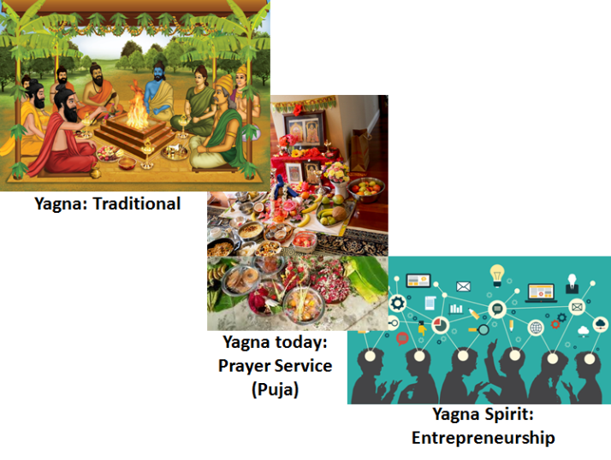
The above manner of living and engagement in life may also be described as the Yagna Spirit applicable to all events, times and ages. The life and mindset of the saint is the metaphor for Yagna spirit. Each of us come into this world without anything and leaves the world the same way. All activities in between are carried out with others under situation and circumstances presented as part of life. The end result is what we are required to do (duty) and the outcome is what happens as a result. This is the Yagna spirit as the lifelong mission.

The Yagna spirit can be seen in practice in every action and in every day of our life. The four pillars of life as well as the four stages described above foster such Yagna Spirit. It is not merely conceptual or hypothetical. As an example, we see this Yagna Spirit alive and well today in our Entrepreneurship culture.

An entrepreneur sets upon a course of journey with a single idea or vision. This goal or focus attracts many people with a diverse set of skills. Each brings his/her best in his skills as the contribution towards the common goal. A company is launched; products are made and sold, revenue generated, jobs created and the profit shared. In many respects it is much similar to the Yagna. There is only one key factor: As long as there is common and collective agreement on the goal and to the extent it serves the needs of every one – through non-attachment – the enterprise succeeds with mutual benefit for all concerned. The idea, thought or vision may survive over the years well into centuries. The founder and all participants come and go as part of their life cycle. Hence the Yagna spirit may not be an ancient thought and practice. Instead it may be the central and essential need to manage the many crises we face today as individuals, family, enterprise or collectively as global issues.

Maya (Illusion):
Maya or illusion is an important concept in Hinduism derived from Vedanta. Along with Karma (pre-ordained or destiny), reincarnation (cycles of birth and death), heaven and hell (metaphysical and extra-terrestrial spaces) and many other terms, the word Maya is widely accepted as part of Hindu mythology. Each of these terms can be also interpreted purely from philosophic point of view without recourse to theology, faith and belief. Let us look at “Maya” from this analytical perspective.

There is a Tamil proverb which translates as: “What you see through your eyes is a lie, what you hear with your ears is also a lie! Truth is only that arrived at after objective thinking and reflection!” This proverb captures the essence of Maya or illusion. All our perceptions, feeling and thoughts are nothing but the reflection of our connectors (Guna) (i.e.) our Knowledge, Ignorance and Bias. To believe that any of our awareness is anything but such reflection is described as illusion or Maya in the Vedic literature. The more educated one becomes on a given subject the more one is aware of the fundamental principles – the laws of nature (Brahman) – behind that subject.

With education and awareness the illusion gradually diminishes. One who does not know the difference between lead and cast iron would merely think of lead as a “heavier cast iron”! One who does not know how to swim would be petrified to jump into a pool fearful for his life, while a swimmer would dive and glide into the water effortlessly. A musician can remain enthralled in the beauty of his music and hold the audience in the same state of mind even for hours at a time! These are but a few examples of how we engage in life. Our ignorance is removed when we learn that lead and cast iron are distinct elements with different atomic structure leading up to the differences in their properties. One such difference is their density. Hence lead is heavier than cast iron for equal volume. Such knowledge helps to distinguish not only between lead and cast iron but across the wide spectrum of metals. Instead of simply believing what we see or hear or know, we reason and enquire. This thinking and reflection leads to more truth and away from our initial illusion. This is suggested by the Tamil proverb described earlier.

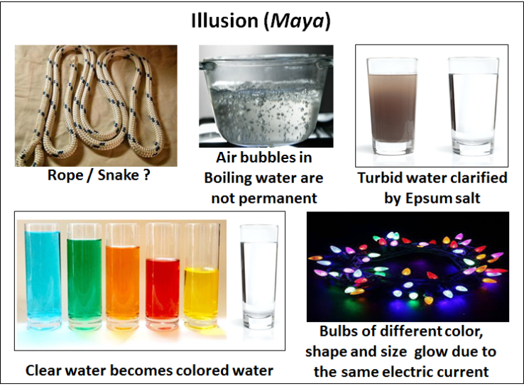
Illusion or Maya need not be thought of in a negative context. It is more important is to be aware of the illusion. Reflection and reasoning is required to go beyond that. This point is made through many analogies. “Serpent and the rope” analogy is frequently noted in Vedanta. The perception that the object is a serpent instills serious fear and concern. The same object when thought of as a rope, it is approached and picked up without any fear at all! The object can be serpent or a rope and hence has to be handled appropriately is logical and well understood. But the perception of fear or lack of fear is illusion, merely based on our knowledge, bias and ignorance (Guna – Connectors) at a given moment. Reflection and reasoning will lead to probing the object and then the appropriate next step. Vedanta states that every aspect of our duality such as fear/bravery, like/dislike, love/hate, friend/enemy, etc. are all outcomes of the illusion or Maya. On further probing, our thoughts, feelings and perceptions for the moment give way to better understanding of the reality. In this process like the mirage or the fog the duality vanishes. We see objects of different shapes and colors (illusion or duality) until we see them as bulbs illuminated by the same electric current! The illusion also makes us believe in each thought, feeling or perception as permanent like being attached to air bubbles in boiling water. The air bubbles merely nucleate on the hot surface (heat transfer), rise up through the pool of water (buoyancy) and dissipate into the atmospheric air (fluid mechanics) at the top surface. Turbid water can be clarified with the addition of a bit of Epsum salt. Clear water depending on the color added to it can be seen as liquid in a spectrum of colors. For one who understands the underlying principles (Brahman) there is a better comprehension of the “why?” With that knowledge many of the differences perceived as the world of plurality disappears. Hence there remains no attachment to specific thought, feeling or perception. For details: https://sipractce.files.wordpress.com/2020/05/athma-bodha-1-03-22-20.pdf

We can continue with many more examples. But, hopefully the point is clear. Influenced by our current knowledge, bias and ignorance without assessing them and probing further through reflection and analysis we tend to engage in actions almost instinctively. This impulsive action and being shocked or surprised by the outcome is illusion or Maya. All our subjective behavior and actions are rooted in illusion. We hear someone speak. Based on our previous experience, opinions and judgements we tend to respond or react. When the response is not to our liking we reinforce our established opinions and judgments. Our actions are a series of impulsive responses rather than based on reflection and reasoning of each situation. We tend to see evidences as inter-connected instead of seeing them as independent. Is it possible to listen to each conversation or statement as independent and stand-alone inputs? Reason and reflect on what was heard and react only to that? This pause, reflection and reasoning preceding any action is Yoga. Our subjectivity slowly diminishes and objectivity increases. It fosters the mindset “Not that I do not know, I do, but I do not know well enough” as stated in Kenopanishad. Such mindset is that of a person who “knows that Brahman”.

We have extensively discussed that anything and everything reflects the laws of nature. Thus any perception, feeling or thought that does not elucidate that can be taken only as the description or the reflection (i.e.) illusion or Maya. Take the case of the musician who holds the audience enthralled in the beauty of his music. This experience reflects the knowledge of the musician and appreciation of the art by the audience. As an isolated event this would appear unique. But it is the same resonance that can be seen when there is a meeting of the minds based on common knowledge and understanding. This symphony of the minds, the resonance based on shared appreciation is the spontaneous outcome whenever there is a deeper understanding and internalizing of the phenomena behind the event. When we begin to see the undivided presence of the same principle and concepts in a seemingly divided set of events, circumstances and experiences we move away from the world of illusion or Maya and into the world of true reality, the universe of Self-realization.

Bliss: Sath Chith Anandam:
Sat-Chit-Ananda is a Sanskrit term that describes the nature of reality. It is conceptualized in Vedic philosophy as God or Brahman (Absolute Reality). It is also a term to describe the experience of realizing the unity and wholeness of all existence.
The individual words meaning is as follows:
Sath: Truth, absolute being or existence-- that which is enduring and unchanging
Chith: Consciousness, awareness, understanding and comprehension
Ananda: Bliss, a state of pure happiness, joy and pleasure

Some say that the experience of sat-chit-ananda is only accessible to a few advanced spiritual masters.. It is stated that it is easier for people to achieve an illuminated mind, but “sat-chit-ananda” is a higher state even than that. In Vedanta, sat-chit-ananda is used as a synonym for the three qualities of Brahman. It may not be necessary or useful for getting caught up in such abstract and idealistic state of mind and attainment. Instead each of the three components can be reflected upon and internalized as much as possible. Let the outcome be the “sat-chit-ananda” as a result of such self-learning and realization.

Truth or Sath on any subject or topic is what we arrive at through systematic study and reflection. It requires observation of the evidences and their analysis to arrive at the fundamental principles or the laws of nature they represent. We have discussed the opposite of truth as illusion or “Maya”. Every professional is trained to explore such truth and its applicability in their field of study. Objectivity is a pre-requisite for the study and exploration of truth. (See earlier section on Subjectivity Vs. Objectivity).

Mind or Chith is the seat of our thoughts and the actions, emotions or feelings they generate. Control your mind, to limit your thoughts; let these few thoughts be directed externally for the larger common good; such goal and focus becomes natural when there is greater level of non-attachment (i.e.) away from “me” and “mine” to “we and ours” limitlessly. This state of mind which is expansive and inclusive of all and exclusive of none is referred to as “Chith”.

Joy as a result of Inner peace and harmony arrived at through the above understanding of the Truth as a result of the above state of Mind is the bliss or “Ananda”.

All of us seek peace and harmony in life. Such outcome is the result of a journey of life with controls on our wandering mind and limits it to a few thoughts. The feelings and emotions are held in check by seeking the truth behind our thoughts. As a result the equilibrium states are clear (Tranquility, Turbulence and Inertial). This clarifies the appropriate actions. Thus the journey continues. The resulting peace and harmony is Sath Chith Ananda. This way of life is also what we have understood as MEAL (Maintaining Equilibrium in Activities and Life).

Though it is a lofty goal that may not be achieved in the practitioner's lifetime, practicing yoga can help move the individual closer to sat-chit-ananda. Practicing Yoga implies Objectivity and Non-attachment. Sat-chit-ananda need not be thought of as an eternal and permanent state of mind. Such joy and bliss can be recognized whenever our observation, thought, reasoning and/or action is un-attached and objective to the highest order. Learn to observe such moments of Sat Chit Ananda in your life and in the life of others. Let those few moments guide you as building blocks for experiencing the same bliss over longer durations and in many actions. Let it become a way of life in due course. Let that be the blessing to we seek in the journey of life.

MEAL: Vedic Philosophy recaptured:
Let us now briefly recapture what we have learned thus far. Maintaining Equilibrium in activities and life (MEAL) is the essence of the Vedic knowledge (i.e.) Vedanta. This management is applicable for any event, any moment or any activity. The same process also applies for the entirety of the life. It is the same methodology through which the Universe and every aspect of it exist according to Vedanta.

MEAL starts with an understanding that “I” as an individual with ability to think, feel and perceive exist enabled by the life giving force, soul, spirit or consciousness. This soul in me that activates my existence is the same as that in any other person, living being or object. Like the deep ocean It merely exists as Universal Consciousness. The omnipresent, invariant, universal, eternal presence is acknowledged through the statement “Everything is Brahman: Sarvam Brahma Mayam”. Like the droplet of water indistinguishable from the body of water in the ocean, the enabler in me is the same as the Universal Consciousness. It is recognized or acknowledged through the statement “I am Brahman: Aham Brahma”.
Acknowledgement and remembering the above is the foundation for any and all aspect of managing any activity and life as a whole. We have understood that Brahman stands as a singular term that can be understood through all the laws of nature known and unknown. With that understanding both the statements – Everything is Brahman; I am Brahman – become readily obvious.

Next step in MEAL is a choice each of us has to make. This is to have clarity of purpose or the goal. Unlike all other objects of nature, only we humans have the ability to distinguish between “I” and “others”. Two pieces of metal placed next to each other will exist merely based on the prevailing laws at their interface. Two animals left close to each other will find a way to interact based on their instincts (also evidence of the laws of nature). When two people are left to co-exist, each can decide to fend for himself or think of collaboration with the other. This choice is unique to human beings.

Vedanta suggests non-attachment is a choice and as the goal. It is focused on “external” to the self. The external implied in Vedanta is the integrated view of our own body, mind and intellect, needs, thoughts and feelings. This goal creates an intellectual separation of “I” the life giving force or the enabler from the enabled (which includes my physical self and everyone and everything else). It is the beginning of the process called Yoga which stands for “Union with the Self (Soul, spirit, Brahman). With this non-attachment we can recognize the prevailing knowledge, bias and ignorance. These are the three ever present connectors (Guna). Their relative proportion creates three equilibrium states (Gunathvam):
- Tranquility – when knowledge prevails over bias and ignorance.
- Turbulence – when our bias prevails over knowledge and ignorance
- Inertial – when our ignorance dominates over knowledge and bias.
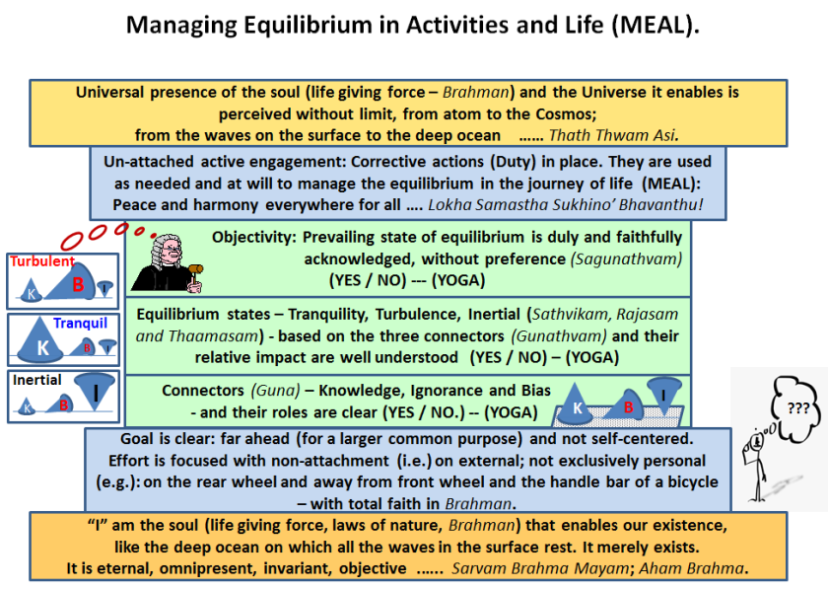
Tranquility leads to general understanding of the situation, harmony and collective progress for all. Turbulence is the foundation for excessive personal attachments, greed, vanity, jealousy, etc. Impulsive actions to meet immediate personal needs never seem to satisfy those needs and wants. Instead they lead to a chain of other actions. Such management of activities is what we see as the life misery! Inertial state results in unrelenting grief, lack of direction and procrastination forever. All our actions, feelings and thoughts are a response to these equilibrium states. If such action, engagement or response is impulsive without further assessment of the equilibrium state, we can identify that as subjective. Subjective engagement in activities is like being caught up in the waves on the surface of the ocean. The unrelenting waves never seem to subside!

Precise determination of the equilibrium state will depend on our un-attached active assessment. This is like the judge who is equally disposed to all available evidences. This manner of assessment with equal disposition to all equilibrium states is a measure of our Objectivity (Sagunathvam).

Objectivity is like the cream that rises to the surface on churning the milk. This requires a foundational belief that there is a rhyme and reason for everything that happens (governed by the laws of nature: Brahman) and a churning tool of reasoning enhanced by non-attachment. Objectivity manifests as follows: If inertial state is acknowledged we initiate actions that foster further engagement to gain new knowledge. The result may be turbulence or tranquility. If it is turbulent we implement the corrective actions towards tranquility. When tranquil we can deliberately seek out areas of ignorance and the engagement continues. It is like a voyager sailing across the sea over the ocean waves, happy to sail under calm weather (tranquility), but also aware that he requires wind currents (turbulence) for his journey and knows there are unexplored territory (inertial) to be pursued as opportunity arises. Vedanta suggests that there is no end to such exploration of these equilibrium states if the end goal is universal (i.e) May there be peace and harmony everywhere for everyone (Lokah Samastha Sukino’ Bhavanthu).

With non-attachment, reflection and reasoning as the SOP, the enlightened person (Yogi) begins to see the above description of MEAL applicable to any and all activities in life. He/she begins to see himself/ herself as the microcosm of the universe at large. Through such emancipation one can see anything and everything exists merely as part of the Universe, enabled by and as a witness of Brahman. This enhanced awareness is summarized in Vedanta as “You and the Universe are integral in each other: Thath Thwam Asi”.

Swami Chinmayananda summarizes Vedanta through a simple schematic:
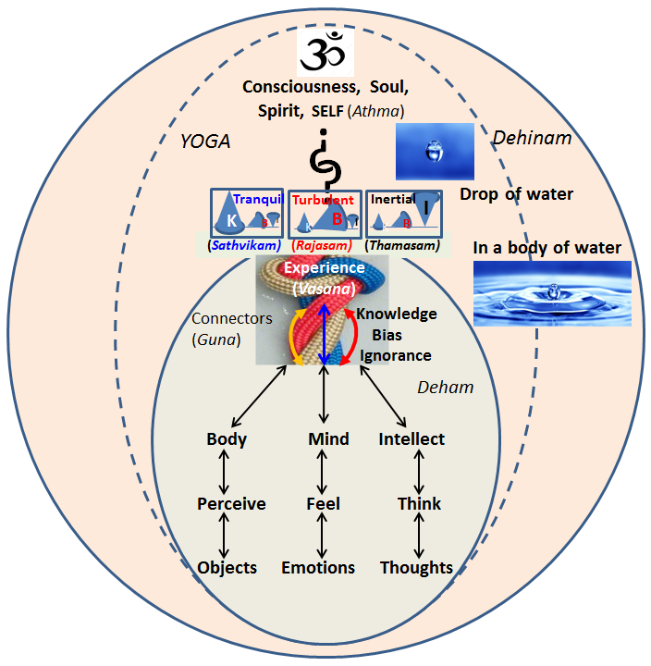
“Every one of us lives in the world of objects, emotions or feelings and thoughts or ideas. We perceive of objects through our sense organs. Through mind we feel the emotions. Through intellect we think of thoughts. Collectively they create our “experiences” which in Sanskrit language is “Vasana”. When the experiences or Vasana are exhausted we become in union with the Consciousness or the Lord”.

We can see the following verse in Kaivalya Upanishad:
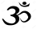
“Use the bondage or attachment to personal preferences (ego) as the lower Arani*, and the spiritual way of life (which seeks to find harmony inward as well as with the outer world as far as one can) symbolized by the higher Arani. Churn one against the other repeatedly and in due course, the wise man burns up all his bondages of individuality and the wisdom of Universal Consciousness – AUM - dawns on him”.
Mandukya Upanishad:
That which is changeless (Aksharam) is “AUM”. All that is cognitive and incognitive, in the past, present and future all that is transcendental and beyond, and all that beyond these three stages of time – everything is “AUM”.

- Arani is a tool made of two pieces of wood – a stick and a cup – when rubbed against each other create a spark used to light the fire for the prayer service (Yagna).

We have seen a similar explanation in Narayaneeyam referenced earlier. This summation can be understood using the figure above. We see that all our experiences are accumulated through our knowledge, ignorance and bias. Like a set of ropes they create the connections with the material or cognitive world. Their equilibrium states can be thought of as the knots that tie us down through our “experiences”. We live in a world of experiences and their effects, which lead to a new set of experiences! Like the waves on the surface of the ocean these experiences are relentless and unending!

The word used to describe any challenge or difficulty in Tamil language is “Chikkal”, which translates into a knot. It is a very appropriate metaphor. Knot is formed when a rope winds itself into a set of incessant interconnected loops. We tend to get wound up in knots in our intellectual, emotional as well physical experiences. Caught up in this web we compound our problems by moving our “knots” from one situation to other. In the end we do not know if we are dealing with a problem of ideas (intellectual), a problem of emotional feelings and the duality as a result (like/dislike, anger/happiness, guilt/good will, etc.) or sheer physical inability. This is the Cognitive world we live in.


But, we have also learned that all these knots (experiences) can be grouped into three categories: three states of balance or equilibrium between the connectors. Non-attachment and objectivity is needed for proper and accurate calibration as well as classification. The knot which appears “real” is no longer present when it is untied. Our experiences which appear real and permeant disappear when we untangle them into their cause and effect governed by the pertinent “laws of nature”. In the end everything can be understood as evidences of and enabled by the infinite laws of nature which merely exist. We see this body of enablers (Brahman) in us, around us, everywhere and all around. When that comprehension sinks in we are no longer the “product of our experiences”. Instead all experiences and everything is the product of the laws of nature (i.e.) Brahman. At that moment or in that frame of mind we are devoid of the experience. Instead we see ourselves as any other object of the universe, each governed by and as evidence of the laws of nature (Brahman). We are part of the changeless. We are in union with the eternal or Universal Consciousness which is also identified as the syllable AUM
https://sipractce.wordpress.com/2016/09/15/untying-a-knot/

In the figure above we see the cognitive and in-cognitive as connected by a set of hooks. In real life the hooks retain their connection only because of a pull or force applied against each other. Through non-attachment and objectivity when we remove this pulling force, the false sense of identity that I am different from the rest of the universe dissipates. The hook or connector holding us connected and shackled to the world of material objects, feelings and emotions disappears. This leads to a genuine sense of liberation or self-realization. In this state we see ourselves even if we are a drop of water same as and indistinguishable from the body of water in the wide open ocean. As mentioned earlier ” the wise man burns up all his bondages of individuality and the wisdom of Universal Consciousness – Om - dawns on him”.

Spiritual evolution: Where do “I” belong?
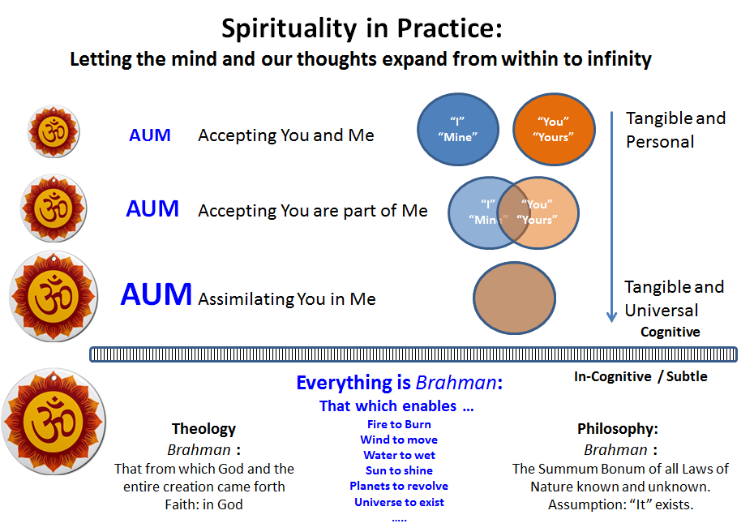
We have come to the conclusion that “Spirituality” in effect is the realization that our physical reality as seen through our body, mind and intellect and their functions is enabled a set of invisible laws of nature identified as the Soul, Spirit or Consciousness. These are but a small subset of the totality of laws of nature that govern and enable the universe as it exists. This enabler of the Universe in its entirety or in any part is identified as Brahman. Hence I am Brahman, the universe is Brahman, everything known and unknown is Brahman! This universal presence of Brahman is also recognized through the symbol AUM.

The in-cognitive Brahman merely exists. It can be understood as the sum total of all the laws of nature. Brahman is also recognized through the God and His creations of which we are all part of.

Keeping in mind that I, you, everyone and everything is Brahman has profound practical implication. We can call this as the Spirituality in Practice. As a beginning “I am Brahman” helps to remove the mystery of who we are? Where did we come from? We are all objects of nature perceivable in one of five layers: Material, Physiological (living); Psychological (emotional), Intellectual (with reasoning, objectivity and non-attachment) and as evidences of laws of nature at work that enables the previous five layers. Immediately we shed the inhibitions and limitation of each of us being isolated individuals of unknown origin. Our birth or beginning is no more a mystery than the death. Both are events of nature that occur when certain aspects of our physiology start and stop. Before and after that we remain as material objects along with all other inanimate material objects of nature! Our emotions and sense of duality (like/dislike) are understood merely as an outcome of our state of mind and the attachments. As we learn and practice non-attachment and objectivity we see no difference between us as individuals and everyone around us. We only see all our experiences as the endless waves on the surface of the ocean. Underneath we are all part of the same deep ocean, the in-cognitive universe of the laws of nature. Taken together everything is Brahman. This expanded view of the mind breaks down the barriers. It accepts you and me as part of the continuum. Gradually this inclusion changes from being immiscible like oil and water. Instead it becomes inseparable like droplets of water in a body of water, accepting you as part of me. In the end the expanded mind perceives only the Brahman everywhere without any separation of any kind. This progressive merging and integration or assimilation are the steps of progression in Spirituality in Practice, as illustrated in the figure above. This expansive and integrated view of the Universe and each of us as individuals is an awe-inspiring aspect of Vedanta.
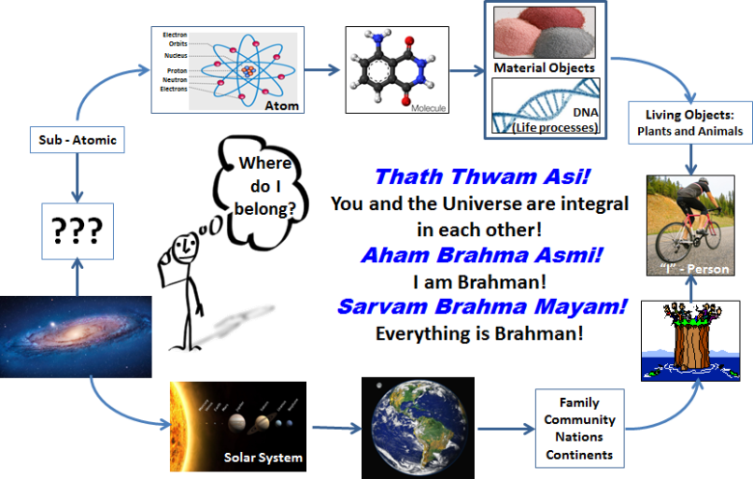
The aphorisms noted in Vedanta are described as Grand Pronouncements (Maha Vakhya). Three of these Maha Vakhya are:
- You and the universe are integral in each other: Thath Thwam Asi
- I am Brahman: Aham Brahma Asmi.
- Everything is Brahman: Sarvam Brahma Mayam.

Each one of them is applicable and can be used to answer the question “Who am I?” at any level of the Universe that we can relate to. You can start your answer beginning from the sub-atomic particles and move to the right. You can also start from the Universe as the starting point and progress to the right as shown in the figure above.
These pronouncements are applicable in every stage or level as we move from left to right. These are the descriptions of the cognitive universe. At the same time through objectivity and non-attachment we can explore our Knowledge, Ignorance and Bias (the connectors) and the equilibrium states (Tranquility, Turbulence and Inertial) they create. As our non-attachment and objectivity rises in quality and perfection our clarity on the prevailing laws of nature become more visible or evident. This exploration of the cognitive and the in-cognitive leads to an understanding of a universality of everything. We wonder at the omnipresence or the eternal Brahman. This is Spirituality?

Session 13: Dec. 24, 2020
Review Questions and answers.
For each question, please check all the answers that apply.
- What is life?
- Life is a collection of our experiences
- Life is what we want it to be?
- Life is destiny from our past?
- Life is whatever happens from birth to death
- Life is one of many cycles of birth and death
- I don’t know
As a general and optimistic outlook one could say “Life is what we want it to be”. A more passive point of view would suggest “Life is destiny from our past”, “one of many cycles of birth and death” invoking faith. Stated in pragmatic terms “Life is whatever happens from birth to death” and it is a collection of experiences.
But we have learned that each experience is not a random occurrence. Instead it is the evidence of our Knowledge, Bias and ignorance. Our experience reflects one of three equilibrium states (Tranquility, Turbulence or Inertial) depending on the dominance of one among these three co-existing connectors. Life can be thought of a relentless journey to explore these connectors and their roles. Such exploration is objective when we as observer maintain a willful separation or non-attachment from all that is observed.
- Equilibrium in life means:
- Speak no evil, see no evil and hear no evil
- Seek the truth through observations and objective analysis
- Belief that everything happens at the will of the God
- Not falling down, just rolling along!
- Being patient and not show any emotions.
- I don’t know
We remain in equilibrium at any time in life when we seek the truth behind our observations. Such effort is enhanced by our objectivity. Remember the old saying “What you see may not be the truth or what you hear. Observe and analyze objectively and unattached. You will get closer to the truth”. That reality reflects the equilibrium and stability in life.
- We live through our:
- Body, Mind and intellect
- Feelings, emotions and perceptions
- Thoughts and ideas
- Will power
- Consciousness
- I don’t know
We perceive of objects through our body. We feel the emotions through our mind. We think of thoughts and ideas through our intellect. Our ability to achieve all of the above is enabled by Consciousness, the invisible force of life, the enabler which is also known as the Spirit, Soul, Athman and Brahman.
- Emotional intelligence is:
- A special type of intelligence
- Feeling the pain of others.
- Thinking on behalf of others
- Understanding and appreciating our common nature
- Ability to accept and live with our differences.
- I don’t know
Emotional intelligence is a special human quality. EI fosters the ability to feel the pain of others, think on behalf of others, Understand and appreciate our common nature, an ability to accept and live with our differences.
- What is spirituality?
- A way of living
- Something to do with holy spirit
- Something related to religion
- Seeking the commonality beyond the differences.
- Something one acquires at old age
- I don’t know
Spirituality is a way of living that radiates Emotional Intelligence. Rooted in the principles of “I am Brahman; Everything is Brahman; You and the Universe are integral in each other” spirituality as a way of life identifies with the relentless commonality beyond all perceived differences.
It is not B, C or E above.
- Spiritual person is:
  - Reflective and contemplative
  - A recluse or monastic, wears minimum clothes
  - Strives to be objective
  - One who has no wants,
  - Prays all the time
  - I don’t know
Spiritual person strives to be objective; to that end he is reflective and contemplative. Objectivity brings with it a degree of non-attachment and hence personal desires and wants are subdued. To be centered in objectivity may at times require high level of emotional stability, overcoming one’s bias and feelings. This periodic course correction is enabled by prayers.
Spiritual person is not a monastic, ascetic seated in prayer all the time, recluse or wears minimum of clothes.
- Spiritual person:
- Highly educated
- Tries to remain non-judgmental
- Has lots of friends
- Has no friends
- Very knowledgeable
- I don’t know
Spiritual person tries to be objective and hence remain non-judgmental. He is always open to all. Such open and welcoming atmosphere leads to lots of friends and a climate to be well informed. Education is the means and knowledge is the end. One of wisdom, objective, unattached, seeking the friendship and welfare of all. Spirituality is a human capability. It should not be mistaken as the domain of educated or talented only.
- Spiritual person
- Is truthful all the time
- Seeks truth as much as possible
- Does not know the difference between truth and lie
- Knows the truth even before he speaks!
- Thinks everyone knows the truth!
- I don’t know
Keeping in mind objectivity and non-attachment as his search lights spiritual person seeks truth as much as possible. Objectivity requires staying away from any pre-disposition such as: truthful all the time; does not know the difference between truth and lie; Knows the truth even before he speaks; thinks everyone knows the truth!
- What does Conscience mean?
- Something inside?
- Being truthful to the best of my ability?
- Being Objective as best as one can be?
- Being alive?
- Connection between my inner and external self.
- I don’t know.
Vedic philosophy describes conscience as the connection between the inner self (the enabler or Consciousness) and external self (body, mind and intellect) engaged in the world of activities.
- Higher Education means:
- Getting higher college degrees
- Respected as knowledgeable person
- Understanding of the fundamentals on any subject matter.
- Ability to use the knowledge to improve the life of oneself and that of others.
- Ability to make lot of money
- I don’t know
Vedanta states that all of us (and for that matter anything in the Universe) is enabled by Brahman. We exist enabled by and as witness to the effects or actions of Brahman. Taken literally this sounds abstract and metaphysical.
We are also told that Brahman is that which enables the fire to burn, wind to move, eyes to wink, lightning to flash in the sky, etc. If we look deeper Brahman could be understood as a metaphor or a singular term that represents all known and unknown laws of nature. It is self-evident that anything and everything we know of or relate to are enabled by laws of nature (i.e.) Brahman. This knowledge also creates an awareness of a separation between the life giving force (Brahman) and all the enabled which we recognize as things, persons and individuals. What we see and observe are our perceptions. We can relate to all that as a result of our knowledge, bias and ignorance and the equilibrium states they create. That is the basis for all human experience.
Exploring the laws of nature at work (Brahman) leads to the understanding of the fundamentals on any subject matter. This is the true knowledge. All forms of education should lead to this capability. This is the higher education.
- Who am I?
- I am made of my physical body, mind and intellect
- I am a product of my experiences
- I am distinct from others.
- I and the Universe are one and the same!
- I am enabled by laws of nature.
- I don’t know.
I am enabled by laws of nature (I am Brahman); I and the Universe are one and the same (Thath Thwam Asi)! Without this knowledge I believe: I am made of my physical body, mind and intellect; I am a product of my experiences; I am distinct from others.

Vedanta and “Free will”:
Free will is the ability to choose between different possible courses of action unimpeded. The choice, decision or action is free, independent and voluntary. Free will is closely linked to the concepts of moral responsibility. Praise, guilt, sin, and other judgements apply only to actions that are freely chosen. Traditionally, only actions that are freely willed are seen as deserving of credit or blame. It is also connected with the concepts of advice, persuasion, punishment and deliberation. The underlying questions are whether we have control over our actions, and if so, what sort of control, and to what extent.
Free will is also the capacity to make choices in which the outcome has not been pre-determined by past events. Religion or theology suggests that only one course of events is possible. It is the ordained course of action as per the God’s will. Everyone and everything acts according to God’s will. Free will suggests that events are not pre-ordained by some super power or God.
Free will is also freedom for action. Free will is opposed to prohibition. Free will as a psychological capacity is to direct one's behavior in a way responsive to reason.

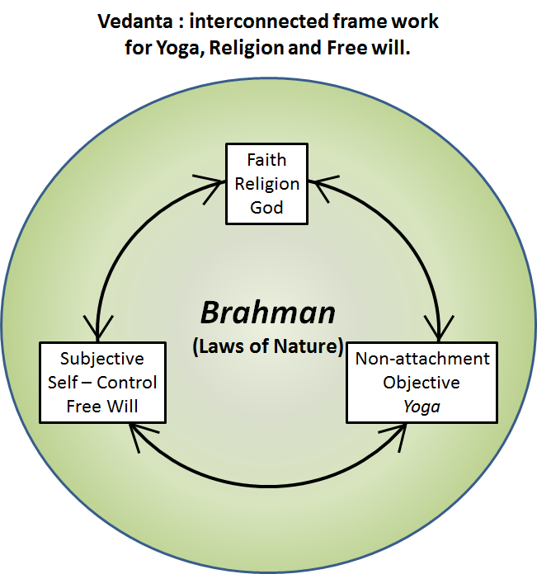
Brahman from the Vedic philosophy is the singular term that represents the enabler of the Universe. We recognize the presence and role of Brahman through the laws of nature. Non-attachment is relinquishing our identity through our body, mind and intellect. Instead we see ourselves as witness and evidence of the Brahman at work.
We see the universality of the laws of nature in anything and everything we can see or relate to. While being individuals we see a seamless connection with everyone and everything. As a result our observation, reasoning, conclusions and actions are objective (inclusive of all and exclusive of none). Any decision and the action as a result is performed with the full knowledge that the prevailing and applicable laws of nature (Brahman) will influence the outcome. Hence I as a decision maker is detached from the outcome, ready to make the next decision. I pursue the course as it is called for (duty) with non-attachment and objectivity.
Our life and course of action is merely the way of nature. There is no praise or blame. It is like the breeze spreading the fragrance or the rain washing away the soil on its path. There is no blame or praise for the breeze and its effect or the flow of water. It is all part of nature. This way of life, this manner of thinking and action is described as “Yoga”.

The above description of Vedanta infers the following: I am free to observe, analyze, infer, decide and pursue any course of action at any time. In that sense the concept of “free will” is in full display. My engagement in life and the outcomes of my actions are pre-ordained in the sense everything is enabled by and implicitly follows the laws of nature (Brahman). The only constraints or boundaries between free will and Yoga are Non-attachment and Objectivity. If these two attributes are not present or if they are deficient in some manner, then the free will shall be governed by personal preferences (Subjectivity). To the extent subjectivity is involved blame and praise are also perceived as the resultant outcomes.

Traditional view of “Free will” would suggest self-control as independence or freedom to think and act on one’s own accord. From the Vedic philosophy, Self-control (Yoga) implies a willful separation between the observer, the life giving force (the soul or the spirit) while engaging in observation, thinking and action. All these cognitive activities are carried out while keeping in mind that the observer and the observed are connected only through our knowledge, ignorance and bias. This leads to increasing level of non-attachment and objectivity. Thus the Traditional view of “Free will” and the Vedanta point of view of free will enabled by Yoga (Union with the “Self”) will merge into each other as our non-attachment and objectivity increases. In other words, to be totally of “Free will” non-attachment and Objectivity are the foundations. Remember that a true Yogi is free and at ease at any place, circumstance, situation or company. Such a Yogi is truly free to speak his mind and express his thoughts!

We can see, observe and learn of a few laws of nature. But is it possible to accept that “everything” is enabled by Laws of nature, known and unknown (i.e.) Brahman? Even if it appears plausible, this requires some degree of faith. This faith is fostered through the description that Brahman created God and from this God the Universe was created. Hence we believe and worship in this God, as part of Vedic religion.
We seek to be non-attached and objective. The entity that represents the ideal state of Non-attachment and Objectivity is described as God. If non-attachment and Objectivity increase in our actions and way of life, then the decisions and outcomes as a result of our free will are the best one can arrive at. Thus duty is performed without attachment to the outcomes or any praise or blame for that. This way of living is seen as divinity in action!

We can now see Vedanta (Vedic Philosophy) as an interconnected framework for “Free will”, “Yoga” and “faith” as illustrated in the figure above.

Under traditional view of “free will” one can say “I did this” which reflects ownership in a personal manner. If it is biased through attachment to “I” and hence desires and attachments for the outcome it reflects “ego”.
On the other hand one could also say “I did this to the best of my ability enabled by the laws of nature as best as I know at this time. I will continue to do this in the same way reflecting my objectivity (without emphasis on personal or self-driven needs and wants and hence non-attachment to the outcome). This would reflect the nature or Brahman. I do have the free will to pursue this course (the mind of a Yogi) or the alternative (to deviate from that).
How do I know what is the most objective and highest level of non-attachment? It would reflect the laws of nature (Brahman) pertinent to the context. When I don’t know much about this or swayed to be subjective and attached, what could I do? I could think and ask “What would God do in this situation? How would He display objectivity and non-attachment?” This ideal course would be seen as divinity in daily life.

Let us take a concrete example to illustrate the above:
We come across a difficult situation in life. We can walk away from that claiming “free will”. Is it? Of course not. It is a decision and action based on attachment to self-driven needs and outcomes.
Instead of walking away we enquire, we probe, we learn from past actions, the proper steps and mistakes of everyone involved. The more objective we are and more non-attached to any preferred outcome, the prevailing Knowledge, bias and ignorance will be clear. Under these circumstances what is the next course of action? We move forward with clear eyes and open mind for the outcome, progress, impact all contributing to the new knowledge, bias and ignorance. Next step, then one more, …. Life goes on with the path and the process being consistent, reliable and the same with objectivity and non-attachment.
As this journey continues there will be moments of doubt, anxiety and uncertainty. There could also be confidence, assurance and certainty. Irrespective of all these dualities the mind is steadied with a faith in a larger power – the Lord – and His guidance to do our best. That emotional comfort is relied upon in each decision making and every action step in the journey of life! In this regard God is not a pre-ordained decision maker bestowing favors or punishment. Instead God is a beacon of light as our ship passes through its journey of life.

Session 14: Dec. 31, 2020
Symbolism used in Vedic Philosophy.
There are many symbols used to precisely capture the details of Vedic Philosophy. We shall use some of them here with an explanation that is relatively easy to remember for our use in our daily life:

Symbolism of AUM:
https://sipractce.wordpress.com/2012/03/22/symbolism-of-aum/
The three sounds of AUM when they are separated cannot lead one beyond mortality; But when the whole of AUM is realized as indivisible and inter-dependent and when that understanding goes on vibrating in the mind, one is freed from fear, being awake or asleep. Prasna Upanishad.
AUM is the supreme symbol of the Lord. AUM is the whole, AUM Affirms; AUM signals the chanting of the hymns from the Vedas. The priest begins with AUM; Spiritual teachers and their students commence with AUM; The student who is established in AUM becomes united with the Lord. Thaitriya Upanishad.
AUM stands for the supreme reality. It is a symbol of what it was, what it is and what it shall be. AUM represents also what lies beyond past, present and future. Mandukya Upanishad.

As we can see the letter representing the symbol “AUM” has a special place and meaning in Vedic Philosophy. It is considered as the letter representation of Brahman (which by definition is indescribable)!


The Sanskrit letter AUM (as illustrated above) has a symbol “3”, which we could use as a reminder of the three connectors. All we perceive and experience are the three equilibrium states as a result of these three connectors. This can also represent the three fold aspects of the cognitive world of Body, Mind and Intellect; Physical/Objects, Emotional/Feelings, Intellectual/Thoughts; awake, asleep, deep sleep; etc. The cognitive world can be represented by any of these as seen through “3” in the symbol
The hook extending away from the “3”, would seem to suggest an extension away from the self, the process of self-control and introspection, while still being connected (living) in the cognitive world.


The “o” in the merely exists. It is not connected with the other parts (representing the cognitive aspects) of AUM. The “o” by its mere presence completes the AUM. Without the “o” the entire symbol of AUM – and by inference all that it represents – is not complete or ceases to exist! These are same descriptions ascribed to Brahman in the Vedic literature: Brahman merely exists; Brahman is wholesome; Brahman has no properties; by Its mere presence everything becomes real (cognitive) and acquire their properties - enables the fire to burn, the wind to blow, etc.; One who understands the Brahman becomes Brahman; I – the self or consciousness – am the Brahman.

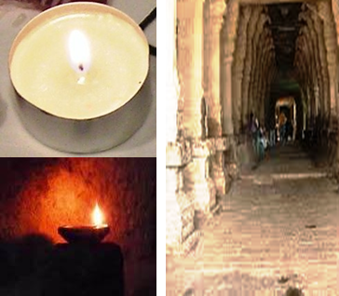
With the above symbolism of AUM in mind, we can re-read the excerpts above from the Upanishads. Now we can see that AUM represents the entire Vedic philosophy. As an example: “The three sounds of AUM when they are separated cannot lead one beyond mortality; But when the whole of AUM is realized as indivisible and inter-dependent and when that understanding goes on vibrating in the mind, one is freed from fear, being awake or asleep”. — When AUM is seen as the symbolism of the entire Vedic philosophy and when such philosophy is understood and appreciated by an individual, for him/her all events of life are causal, governed by the connectors; the entire life (or every moment) is changeless, since every moment is a mere repeat of the moment before or after (with the consciousness merely engaged in the process of observation and analysis of the connectors of knowledge, bias and ignorance and their inter-play)!

Symbolism of the lamp at the Altar:
Hindu Temples have a well-defined architecture. The main idol is placed in the sanctum, which has its main entrance facing the front side of the temple. Any one at the main entrance can have an unimpeded view of the sanctum. This architectural feature of the temple is marvelous. Any one strolling along the road can take a moment to offer their prayers, with a direct line of sight to the idol! With the sanctum generally deep inside and far away, behind the many entrance doors, the idol could be hardly seen from that distance. The larger the temple less the chances to view the idol for far away worship. But, one could recognize the sanctum through the steady glow of the oil lamp placed near the idol. In due course the steady and un-flickering flame of the oil lamp has become the visible representation of the idol itself.

Philosophy provides the reasoning behind the ideals we seek to live by in our daily life. It is an analytical pathway to better understand the visible and invisible. Idols we worship are the visible symbols of the invisible ideals. When we see the flame of the oil lamp, we implicitly understand that we had witnessed the idol and the God it represents!
The lamp in the sanctum and its visible glow from far away is also a visible symbol of the philosophy (which is often elusive and appears to be far beyond our reach) itself. The prayer chanted from Upanishad during prayer service reflects this thought:
The sun does not shine and illuminate you, nor the moon and the stars, nor the flashes of lightning. How can this light from this lamp illuminate thee (Brahman)? Bless me with the wisdom to see that light through which all else shines! Katha Upanishad 2.2.15
Neither the sun nor the moon nor the fire shines there; having reached that place no one returns; that is My abode. Baghawath Geetha. 15.6.
“The un-wavering smile of a Yogi (one of self-control and constant internal or self-reflection) is like the glow of a steady, un-flickering flame of the lamp” Baghawath Geetha. 6. 19.

Candle or oil lamp and its components:
https://sipractce.wordpress.com/2019/10/24/diwali-festival-of-lights-a-philosophic-reflection-on-oil-lamp/

In an oil lamp, the earthen cup or the brass container holds the oil. In a candle we have the candle holder, wax and the wick.
The wick soaked in oil provides the channel through which the oil is drawn from one end to the other, where it burns to create the flame. While much of the oil or wax is consumed through burning or combustion there is also a small and gradual transformation of the wick into carbon, which burns into ash as well. This transformation leads to the flame, its glow and the illumination.
The glow of the flame illumines the surroundings. As a result we see the lamp as well as all the space that is illuminated. The glow from the oil lamp is same as the light from a candle or any other source of illumination.

The components of the oil lamp are the base or the cup, the oil and the wick.

The earthen cup or the candle holder is stable. Unless broken into pieces or cracked, the base can be used for ever. There are lamps and candle holders that are several centuries old used even today. This stability of material objects is amazing in a world where change is assumed to be normal and even expected. That nature of the world or the universe that is changeless on its own accord, we recognize as Inertia or Thaamasam. It is also a symbol of our “ignorance” which does not change on its own accord!

The oil is volatile. It freezes into a solid at low temperatures or vaporizes at higher temperatures. Ambient conditions – the surroundings – have a great influence on the properties or behavior of the oil. This is another aspect of nature. We call this property as Turbulence or Rajasam. It is also a symbol of our bias or emotional response, which change with time and circumstances. Just like the oil our emotions and bias (based on partial or incomplete knowledge) are shaped by the container (our body, mind and intellect)!

The wick transforms the volatile oil in the stable container into the flame or illumination. It is called Sathvikam (Tranquility through knowledge and understanding). Thus we see the oil lamp as a representation of the three ever present attributes (Guna) – and their interplay (i.e.) Tranquility, Turbulence and Inertia.

The flame creates the glow, leading to illumination. Thanks to this illumination we see objects in and around the lamp. We become aware of their presence or existence. Through this illumination we see the inert lamp, the volatile oil and the transformative wick, the flame and all objects that are illumined. The enabler of all of these – the visible objects, the combustion that enables the flame, the flame that enables the illumination and the illumination that enables visibility in sum total represent Brahman. We exist merely as a witness and the glow and the vision derived from Brahman – I am Brahman. I the observer and all that around me (the observed) are all part of the same enabler. Everything exists in unison – Thath Thwam Asi !

There is nothing good or bad about turbulence or inertia. They are the aspects of nature that enable life as we know of it. Lamp as a source of light, acquires all its merits only because of the stable or inertial container and the turbulent or volatile fluid contained in it! Without these two – stability as well volatility (change) – there is no flame and hence no light and thus nothing for us to recognize as the lamp! Similarly without ignorance and bias (leading to emotional responses) we cannot imagine the daily life as we know of it! While knowledge and understanding is good and useful, it arises only when we overcome ignorance and bias. Hence to acquire knowledge one has to be respectful and aware of our ignorance and bias. This analytical mind with equal regard for knowledge, bias and ignorance leads to “Objectivity” (Sagunathvam).

Everything we know and comprehend (and describe as life or universe) is enabled through our knowledge, ignorance and bias. Our understanding (Wisdom) of these three features enables us to become aware of everything in and around us. Such self-reflection seeking objectivity is called “Yoga”. The ideal person of such objectivity in self-reflection is described as GOD (Yoga Ishwara – Chief among the Yogis). The wisdom of such reflection leads us to see that which enables everything else. It is called Brahman. I exist enabled by and as a witness to the role of these three features (Guna), the vision derived there from – I am Brahman. I the observer and all that around me (the observed) are all part of the same Universe – Thath Thwam Asi !

The wick is relatively insignificant part of the lamp, in terms of its weight, size, volume, etc. It is very easy to ignore or dismiss the existence of a wick. It does not serve any purpose unless it plays its transformative role – of transporting the oil, creating a space of controlled combustion and being consumed gradually as part of this transformation! The same can be said of our intellect and the role it plays in our thoughts and emotions. Which part of our body is the home for our intellect? If you say “mind” or “brain” is it not a very small part of who we are? In our daily stress and pressures, it is possible to relegate the mind and its role largely for our emotions (turbulence). It requires a concerted effort to make a significant role for the mind and the transformation it can create for enhanced knowledge. This process of self-reflection and contemplation is Yoga.

The flame of a lamp enables us to see all the objects in its glow. It is our understanding – the glow – through which we comprehend everything around us and also the very enablers of such knowledge (i.e) of our body, mind and intellect. Illumination is perceived only as long as there is the glow of the lamp. Darkness and illumination are complements of each other. The same goes for knowledge and ignorance on any subject. Where there is illumination there is no darkness. When the illumination is not adequate our vision diminishes and we rely on guess work or judgment. This uncertain nature, with respect to our knowledge is the source of our bias or turbulence! Every aspect of above statements is conceived as Brahman – self-evident truth or laws of nature that merely exist.

Just as the illumination through the flame of the lamp, makes all else visible, all that we know is the result of our understanding though our knowledge of the nature and their governing laws. This knowledge – that accepts everything as parts of nature and everything is enabled by the laws of nature – is the only true knowledge (Brahman). On comprehending this knowledge, one acquires a stable frame of mind from which one does not return to the life of perturbations caused by our limited knowledge, bias and ignorance. In an ideal sense God is seen as the repository of such undeterred universal comprehension.

Yoga and Meditation:

We are all aware of Yoga as a program for better physical fitness. Many poses (Asana) are learned and practiced as part of Yoga exercise. Breathing and its control is also part of Yoga training. Meditation is a version of Yoga where the training focusses on controlling the mind to minimize our thoughts and their influence. While such control of the mind and our thoughts is essential all the time, meditation as a practice helps to enhance this capability.
It is obvious that Yoga and Meditation are practiced voluntarily, on one’s own accord. No one can force you into the Yoga poses and certainly no one can influence how you think or minimize your thoughts. Yoga and Meditation are physical processes for “Self-Control”.
More complex the Yoga pose, greater the need for concentration and self-awareness of the various parts of the body, their movement and control. This conscious and voluntary control of the body functions practiced through Yoga poses is like the first or preliminary step in walking or bicycle riding. Eventually such self-control of the body and its movements should happen at will or become second nature. Then the self-control should progress to the mind and the control of our thoughts and feelings. Meditation practice is meant for that.
Let us take this to the next step. You are in a Yoga pose or seated in meditation. Let each thought that comes to your mind pass by without hesitation. Can you do that? Many thoughts are easier to let go and pass by. Some are more difficult. This hesitation is a reflection of our attachment or subjectivity.
To minimize your thoughts can you simply remain focused on your breathing? Do you see them as the waves coming up to the shore subsiding and returning back to the ocean? Can you maintain this balanced frame of mind? It is the evidence of self-control.
While in your Yoga pose or meditation can you reflect on each part of your body? It is alive and it is part of you. But does the part represent the whole of you as a person? Of course not. Your whole person does not reject any part of you either. In the same fashion you are part of the universe, but can you see the universe with you as a small part in it (Thath Thwam Asi)?

Bird in an open cage:

This image is frequently used in Vedic Philosophy. Conditioned by its training and habits a parrot remains inside the cage even when the door is left open. The wide open space and the freedom to be gained is well within its reach. Yet the parrot remains inside the cage. Finally when it gathers sufficient motivation or courage to explore it finds the open door. Eventually it flies away and finds its natural way of living in the open space and in the trees.
Every one of us is conditioned from birth with the notions of “I” as an individual with our date of birth, age, parents, gender, religion, education, economic standards, nationality, ….. Like a caged bird we live contained in this limited space that we believe each of us belong to.
Vedic philosophy points out that all of us are one and the same as (a) material objects, (b) as living beings, (c) as creatures with emotions and thoughts and (d) possessing certain knowledge/bias/Ignorance each moment which determines our “experience” for that moment. It is this “experience” – Vasana – that keeps us as individuals and away from our commonality in all these different layers. Vedanta also clarifies that in all these four layers we faithfully follow the laws of nature. Thus we merely reflect the role and effects of these invisible and ever present laws. They merely exist. They are invariant of time, place, people, and circumstances. In that sense they are ultimate in their Objectivity. These abstract, intangible, invisible, ever present laws of nature are collectively referred to as Brahman. Hence the true knowledge is that we are not caged birds with our limited space. Instead we are the birds free to fly in the open space, to be at ease with anyone and anywhere. This freedom is proclaimed as “I am Brahman; Thath Thwam Asi”! Vedanta identifies this freedom and joy through the proclamation: “Oh! You are the children of immortality”!

Brahman: The intangible and the tangible:
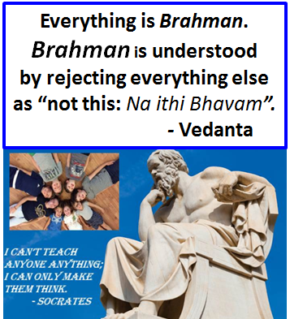
Socratic process is a well-established methodology to think, reason and thus find new knowledge. The un-known comes to the surface by asking more questions for every answer to the previous question. In the end what is under the surface, that which is implicit becomes explicit, visible and evident to everyone. Socratic process is summarized as:
“I cannot teach anyone anything; I can only make them think”.

Vedanta on the other hand leads us to the conclusion that all that we believe and understand as “explicit”, visible, logical, tangible are merely the reflection or shadow of something invisible and intangible Brahman.
Descriptions that infer Brahman include:
That which makes the fire to burn, wind to move, water to wet, eyes to see, ears to hear, eyelids to wink, flashes of lightning in the sky, ………..
That which is eternal, ever present, invisible, enabler of everything and hence the entire Universe.
That which is known, but not sufficiently known in its entirety.
That which is understood by negating everything that can be understood (Na Ithi Bhavam).
That which is the unifier among all the differences seen or perceived or understood.
That which is not known by itself, but understood through its effects.
………….
When all of the above descriptions are considered in summation we come to the conclusion that Brahman represents the Universe of Laws of Nature enabled by which everything we know and the Universe as a whole exists.

Session 15:
This discussion course has been a modest effort to bring together the vast body of knowledge known as Vedic Philosophy or Vedanta. We hope by this time you have come to accept the view that Vedic philosophy is a way of life. It can be viewed as a tool for objectivity and scientific analysis applicable to any profession. It can also be seen as a set of principles and guidelines expected of any religion. It also provides means to cope with life and any aspect of it generally observed as “experience”. The guidelines and formulations of Vedic philosophy would appear to be universal in their appeal for the benefit of individuals, family, community, society and the universe at large. In that sense the appeal “Sarve’ Janaaha Sukino’ Bhavanthu!” – May everyone live and indeed everything exist with happiness, peace and harmony – may be more practical and realistic outcome than theoretical and conceptual.

There are a series of issues each of us need to confront at some time or another in our life. Some of them include:
- Inter-dependence Vs. Independence?
- Social and cultural dependence Vs. Moral and Ethical independence?
- Authority Vs. Harmony?
- Mutual respect and Equality Vs. Bias and polarization?
- Skill specific education Vs. Philosophic education?
- Knowledge worker vs. Knowledge Society ?
- “Informed” person Vs. “Educated” person?
These questions are relevant to us as individuals, as part of a family, society, tea,, community, nation or humanity at large. Vedic Philosophy may be a unifying force and means to address all these questions. Vedic philosophy may also be the means to find common answers and solutions.

These questions can be addressed by everyone on their own for self-development. These questions can also be addressed as they pertain to a family, group or society at large. In every case we come to the conclusion that “I” – the focus of attention or analysis – and the Universe at large (everything external) are integral and inseparable from each other (Thath Thwam Asi). Everything exists enabled by the laws of nature at work (Sarvam Brahma Mayam). Learn to observe this commonality. The larger common goal or purpose will become clearer. Pursue such goals for common good. All (you and everyone and everything else) will benefit together. “Sarve’ Janaaha Sukino’ Bhavanthu!” – May everyone live and indeed everything exist with happiness, peace and harmony!

The boom and bust through economic cycles has brought humanity in the 21st century with lots of progress in terms of human comforts for those who have access to them. For the rest it is a matter of steady decline with challenges for survival. There is a common need for strengthening and reinforcement of all our social fabric as well as our spiritual inner core. Applying the principles of Vedic Philosophy may be more of an urgent need than a matter of intellectual curiosity.

“We are now in an economic order in which knowledge, not labor or raw material or capital is the key resource; a social order in which inequality based on knowledge is a major challenge; a polity in which government cannot be looked to for solving social and economic problems” according to Peter F. Drukker, father of modern management. Farm workers, industrial workers, domestic or service workers are all being replaced by “technology” workers. Each of them being a coherent, recognizable group is being reduced to just another “pressure group”. In this upheaval any worker in any field is required to be a system thinker and transformational reflecting the needs of the users. Emotional Intelligence, objectivity and reliance on common governing laws (of nature) are essential for success for every modern day worker as he/she transforms into a professional. Vedic philosophy would seem to provide the frame work for this much needed transformation of any professional into a practicing philosopher.

Issues of concern today in USA may be listed as: Education, Health Care, Environment, Religious Freedom, Employment, Economic opportunities, Immigration, Marriage, Gender equality, Racial relations, ………. These are also the issues confronted by all in any nation across the globe. As competition grows, political, social, ecological, and economic issues are hotly contested. Justice in matters pertaining to class, gender, and access to desirable resources remains an elusive goal. The loss of civic trust and social cohesion as a result is real even if it is unquantifiable. Vedic philosophy and the way of life it enables “Sarve’ Janaaha Sukino’ Bhavanthu!” – May everyone live and indeed everything exist with happiness, peace and harmony – may be the much needed approach for the modern society everywhere.

It should be clear that learning and internalizing Vedic philosophy is not synonymous with giving up the material world and its way of life. Instead it is a mindset, a way of life that brings peace and harmony to us as individuals as well as everyone and everything around without regard to economic conditions, social standing, religious or political allegiance, nationality or ethnic origin, etc. Nature or the Universe knows no distinctions along these lines. We are part of nature. We can identify ourselves as one with all, without self-imposed distinctions. This self-awareness and objectivity it fosters is good for us as individuals to live a life of peace and harmony with genuine physical fitness as well as psychological and emotional comfort. It is the same awareness through which the “self” is identified limitlessly with everything else, the “other”. The objectivity and non-attachment it fosters leads to peace and harmony for all. Let us strive hard to internalize these concepts. Let these seeds grow into plants and yield fruits for the benefit of the self and for many it can include under its canopy. “Sarve’ Janaaha Sukino’ Bhavanthu!” – May everyone live and indeed everything exist with happiness, peace and harmony.

There is a metaphor in Katha Upanishad that summarizes the Vedic philosophy. We can use this as our summary as we come to the conclusion of this Discussion course. Thank you for your participation and engagement. Hari Om.

Chariot and the Charioteer:
The body is like a chariot to which the senses are yoked like horses. Mind through the rein (of Knowledge, Bias and Ignorance) enable the charioteer, viz., our understanding, to hold the horses (i.e.) the senses in check. The Soul rides on the chariot, and the road is the world of objects over which the senses move. If the reins are not held firmly and wisely, the senses, like vicious horses, will get out of control and the chariot will not reach the goal, but will go round and round in cycles of births and re-births.
Any person of wisdom who controls his mind, his senses will be like good horses driven by a good
driver. Kathopanishad.



Figure 20.5.

Chariot and the passenger: Body, Mind and Intellect
Horses: Sense organs (through which observations are gained)
Reins: Connectors (Guna): Knowledge, Ignorance and Bias
Tension through the reins: Equilibrium states of Tranquility,
Turbulence and Inertial.
Charioteer: Reflective mind that discriminates between
Subjectivity Vs. Objectivity;
Non-attachment
The enabler (laws of nature); the Soul, Consciousness.
Road: The journey of life.

Om Thath Sath Brahmarpanam Astu!
May all manner of existence be dedicated to unattached active engagement!

